SLO Cycle Assessment Form
Please type on this form. Do not submit handwritten forms.

Course:  Practical Acctg: BUS 010 |  | Semester data collected:  Fall 2012 |  | Date this form was completed:  December 12, 2012
# of sections offered:  2 | # of sections assessed:  2 |  | Data Collected from: (Check all that apply)  FT Faculty ___X___ PT Faculty ______  Day ____X__ Evening _____ Hybrid/Online_____ Weekend______
1. People involved in summarizing & evaluating data (minimum of two) |  |  | Vicki Viloria  Craig Blek
2. Please list the SLO(s) that was (were) assessed. Include the description listed on the Course Record of Outline. |  |  | Demonstrate knowledge of accounting concepts to analyze, journalize, and post transactions. (ILO1, ILO2, ILO3, ILO4, ILO5)
3. Data results  Briefly summarize the data. (Please see instructions). |  |  | Used Chapter 4 Exam to evaluate. See Chart Below:  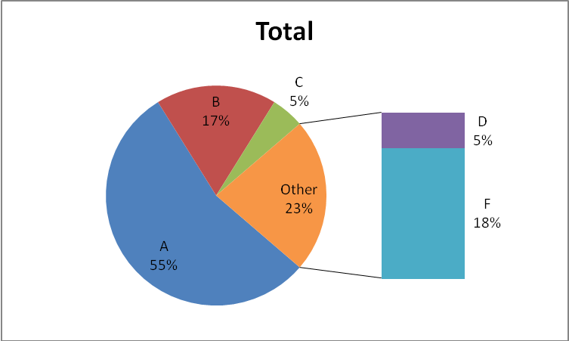
4a. Course/Program Improvements  Please describe what change(s) you plan to implement based on the above results  4b. Will this include a change to the curriculum (i.e., course outline)?  Yes  No X |  |  | Create more handouts and make them available on Blackboard so that students can access easier.
5. How did the SLO(s) contribute to student acquisition of the Institutional Learning Outcome(s) (ILOs)?  For example, if ILO #1 (communication skills) was identified as being related to this SLO, then please write a sentence or two supporting the relationship.  IVC’s 5 ILOs:  ILO1 = Communication Skills  ILO2 = Critical Thinking Skills  ILO3 = Personal Responsibility  ILO4 = Information Literacy  ILO5 = Global Awareness |  |  | ILO2: Students evaluated business transaction for appropriate accounts; determined whether the account increased or decreased; and assessed whether the increase or decrease required a debit or a credit. Then using the appropriate form, the student prepared the journal entry.
6. Next Steps  Was the process effective? Will you change the outcome/assessment (e.g., alter the SLO, assessment, faculty discussion process, strategy for providing SLO to students)?  If so, how? |  |  | The process was effective. I would change the SLO to “Demonstrate knowledge of accounting concepts to analyze and journalize the transactions.” I believe that students need to know the theories behind accounting because most Accounting systems are computerized. In a computerized system, the journals are automatically posted to the General Ledger after the journal is entered. I use the T accounts in Chapter 3 to demonstrate the posting of journals.
7. After Thoughts

Feel free to celebrate, vent, or otherwise discuss the process

For instructions on how to fill out this form, click here:

SLO Cycle Assessment Form Guidelines

Or visit the IVC SLO Website: http://www.imperial.edu/faculty-and-staff/campus-committees/student-learning-outcomes/slo-forms-and-handouts/

