SLO Cycle Assessment Form

1. Course Number &  Date form was completed | Course: BUS 164 | Date: September 27, 2012
2. People involved in summarizing & evaluating data (minimum of two) | Judy Santistevan, Business Professor  Angie Ruiz, Business Professor
3. Semester data were collected (e.g., Spring 2011) | Spring 2012
4. Please list the SLO(s) that was (were) assessed. Write it out. | SLO 2: Design and create an agenda with the daily events of retreat
5. List all forms of assessment that were used for this cycle assessment (e.g., research paper rubric, skills scenario, multiple choice exam) | 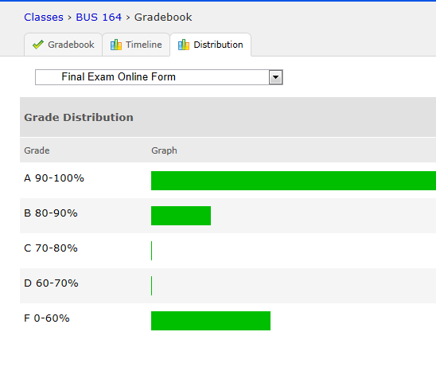
6. Data results  Briefly summarize the data. | 15 out of 19 students passed the final online form exam. The remaining 4 students did not take the exam.
7a. Course/Program Improvements  Please describe what change(s) you plan to implement based on the above results  7b. Will this include a change to the curriculum (i.e., course outline)?  Yes  No | Reinforce Personal Responsibility which is one of IVC’s Institutional Student Learning Outcome in order to have close to a 100% exam completion.
8. When SLOs were previously written, Institutional Learning Outcomes (ILOs) were identified as part of that process.  How did the SLO(s) contribute to student acquisition of the Institutional Learning Outcome(s) (ILOs)?  For example, if ILO #1 (communication skills) was identified as being related to this SLO, then please write a sentence or two supporting the relationship.  IVC’s 5 ILOs:  ILO1 = Communication Skills  ILO2 = Critical Thinking Skills  ILO3 = Personal Responsibility  ILO4 = Information Literacy  ILO5 = Global Awareness | Communication skills, information literacy and critical thinking skills were identified in the student learning outcome identified. Students had to analyze information and decide how information was going to be organized and placed on an online form in order to communicate it the best possible.
9. Next year  Was the process effective? Will you change the outcome/assessment (e.g., alter the SLO, assessment, faculty discussion process, strategy for providing SLO to students)?  If so, how? | I will reinforce the concepts of how to develop an online form in order for students to improve their skills.
10. After Thoughts

Feel free to celebrate, vent, or otherwise discuss the process

The SLO Cycle Assessment Form Guidelines

1. Please list the course number and date that the cycle assessment form was completed.

2. To encourage collaboration and the sharing of ideas, each form must be completed by at least two people. If you are the only one teaching the course, you are encourage to share your data results and improvement methods with at least one other member of the faculty, administration, staff or student population. Please list the names of all who were involved in summarizing or evaluating the data.

3. Include the semester when the data were collected (e.g., Spring 2011).

4. List the SLO(s) that was (were) assessed (e.g., “identify, create, and critique oral argument”).

5. Include any and all assessment tools that were used to collect data for this cycle assessment. They do not need to be attached, but listed. For example, if five faculty members were part of the process, maybe all faculty members used a research paper rubric. In another example, maybe the five faculty members all used a different assessment tool: research paper rubric, oral presentation rubric, multiple choice exam, skills scenario, and short essay.

6. Please summarize the data that you collected. Include how well students scored on the assessment. You might also include: how many instructors submitted data (fulltime, part-time); the types of data that were submitted (rubric scores, practical test results, etc); and, as appropriate, if a cross-section of classes (day, evening, online) were assessed. For example, if a rubric was used, you might discuss the number of students who scored 1, 2, 3, or 4, on the rubric. Your original data results, or your raw data, should be kept within your department for three years.

7a. This is an opportunity to have a rich discussion with others involved in education. Please describe any changes that will be implemented based on the data. Changes might be made to class activities, assignment instructions, evaluations, topics taught in class, or the course outline of record, etc. You might include when the changes will be implemented and, if a comparison is to be made, when the next round of data will be collected (e.g., Fall 2012).

7b. Answer “Yes” or “No” to the curriculum question – if yes, please briefly explain.

8. This recently added section is very important because it allows us to document different ways that students are acquiring the 5 ILOs. We state that “Upon completion of a degree, program, or certificate, a student will complete coursework at Imperial Valley College demonstrating competency in communicating skills, critical thinking skills, personal responsibility, information literacy, and global awareness.” We need to demonstrate that this is occurring. Please refer to the “Strive for Five” form for more of an in-depth description of ILOs.

9. This provides an opportunity to discuss what went well and what could be improved. If the SLO needs to be tweaked or more outcomes/assessments need to be included you might want to do that now while the information is fresh. This may allow faculty to modify SLO(s) for next year and include them on next year’s syllabus.

10. Please share your thoughts, feelings, and ideas on IVC’s SLO process thus far.

/tmp/in/input.doc

