Directions for identifying SLO’s in CurricUNET

If you are a first time user of CurricUNET, you will need to contact Dixie Krimm at [dixie.krimm@imperial.edu](mailto:dixie.krimm@imperial.edu) or at extension 6344, to receive training and to ensure the correct discipline(s) have been assigned to you.

Go to: [www.curricunet.com/imperial](http://www.curricunet.com/imperial)

Login: username: firstname.lastname

Password: changeme (for first time login) (make sure to go into Personal Info to change your password)

Right now, Spring 2011 most need to add SLO’s and Assignments, and update textbooks. At this time please use the course modification option for these changes.

1. Once logged in, for course modifications, click on Courses under the “Build” title.

2. Click on “Course Modification”

3. Under Course Search, choose your discipline (you can leave the rest blank or put in the options if

you want), then click OK.

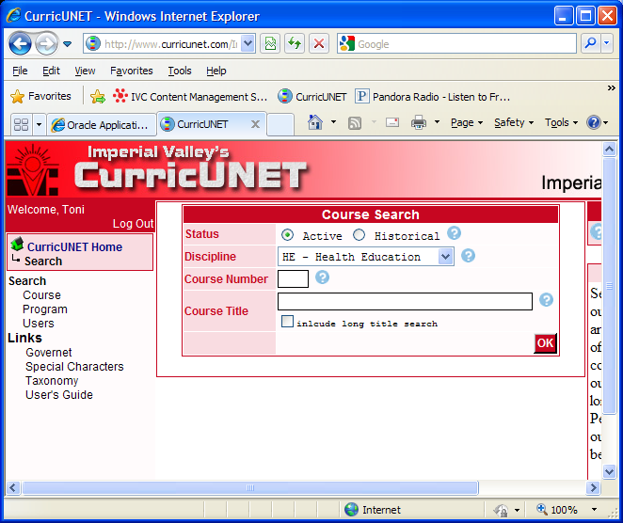

4a. Use the [Copy Course](http://www.curricunet.com/Imperial/search/course/copy_course.cfm?courses_id=757) copy course icon and select the Course Revision option (please include the rationale, such as update to SLO’s, add assignments, update textbooks, etc.)

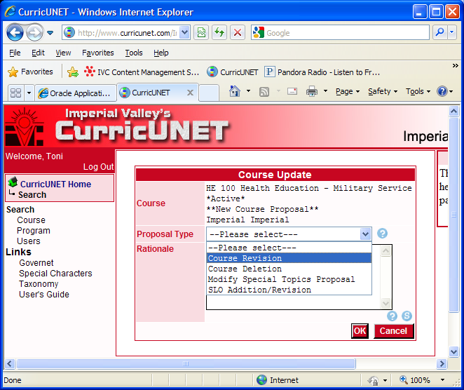

4. b * In the future when updating SLO’s only you can use the SLO Addition/Revision option. (please include the rationale, “to update SLO’s only”)

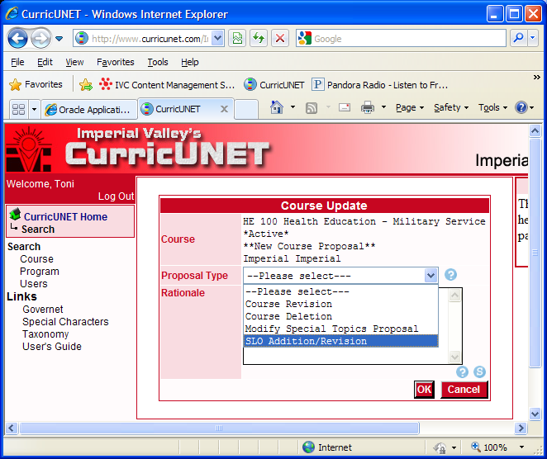

5. The course will open to allow for revisions as stated in your rationale. For the purpose of this document we will focus on the updating to the SLO section.

Under the Course Checklist click on Student Learning Outcomes

6. Enter the SLO’s one at a time, do not number (the system will number itself), make sure to include the ILO(s) that correspond to the SLO in the format indicated. (You do not need to include the lead in statement).

Then click Add, do this for each SLO.

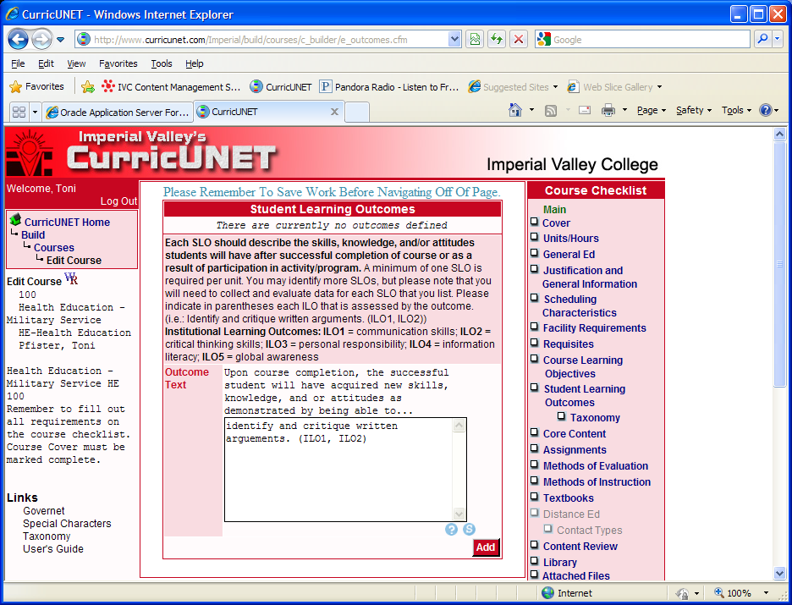

7. Once you have completed the updates, Click on “Cover”, make sure to check off the changes made, click save and then click finish. You will then be able to submit the document.