SLO Cycle Assessment Form

1. Course Number &  Date form was completed | Course:  BIOL 100 | Date: 11/28/11
2. People involved in summarizing & evaluating data (minimum of two) | Daniel Gilison  Tom Morrell
3. Semester data was collected (e.g., Spring 2011) | Spring 2011
4. Please list the SLO(s) that was (were) assessed. Write it out. | Perform lab activities properly and correctly analyze lab data. (ILO1, 2)
5. Data results  Briefly summarize the results of the data. | 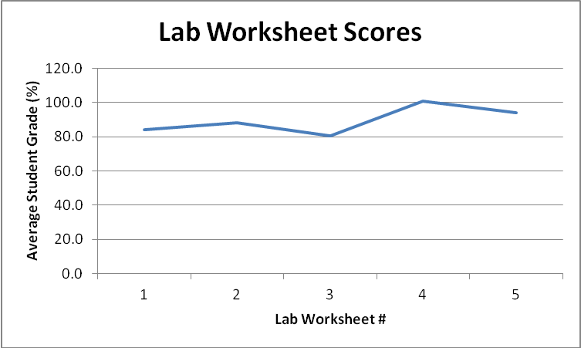  In this hybrid BIOL100 class, students had to turn in lab worksheets at the end of each lab meeting. Because lab worksheets varied in points, I used the % score for each lab worksheet.  These lab worksheets allow students to submit their data that they collected during the labs, and to answer questions dealing with data analysis. As the above graph shows, as the students progressed throughout the semester, their scores on the lab worksheets improved, showing that the students were able to master the ability to analyze their lab data properly.
6a. Course/Program Improvements  Please describe what change(s) you plan to implement based on the above results  6b. Will this include a change to the curriculum (i.e., course outline)?  Yes  No X | Currently, we do not plan on changing anything to the curriculum for BIOL 100.
7. When SLOs were previously written, Institutional Learning Outcomes (ILOs) were identified as part of that process.  How did the SLO(s) contribute to student acquisition of the Institutional Learning Outcome(s) (ILOs)?  For example, if ILO #1 (communication skills) was identified as being related to this SLO, then please write a sentence or two supporting the relationship.  IVC’s 5 ILOs:  ILO1 = Communication Skills  ILO2 = Critical Thinking Skills  ILO3 = Personal Responsibility  ILO4 = Information Literacy  ILO5 = Global Awareness | This particular SLO contributes to two different ILOs – ILO1 (Communication Skills), and ILO2 (Critical Thinking Skills). Students have to write out answers, and they are aware that they can lose up to 20% of the points on each written assignment due to excessive spelling and/or grammatical errors. This ensures that they are improving their communication skills throughout the semester. Also, students are asked open-ended questions about their data that requires proper analysis of their data to achieve the correct answer. This is making sure that they can critically think about their data properly.
8. Next year  Was the process effective? Will you change the outcome/assessment (e.g., alter the SLO, assessment, faculty discussion process, strategy for providing SLO to students)?  If so, how? | This is the first time assessing this specific SLO, so I will have to address this question again next time.
9. After Thoughts

Feel free to celebrate, vent, or otherwise discuss the process

The SLO Cycle Assessment Form Guidelines

1. Please list the course number and date that cycle assessment form was completed.

2. To encourage collaboration and the sharing of ideas, each form must be completed by at least two people. If you are the only one teaching the course, you are encourage to share your data results and improvement methods with at least one other member of the faculty, administration, staff or student population. Please list the names of all who were involved in summarizing or evaluating the data.

3. Include the semester when the data was included (e.g., Spring 2011).

4. List the SLO(s) that was (were) assessed (e.g., “identify, create, and critique oral argument”).

5. Please summarize the data that you collected. Include how well students scored on the assessment. You might also include: how many instructors submitted data (fulltime, parttime); the type of data that was submitted (rubric scores, practical test results, etc); and, as appropriate, if a cross-section of classes (day, evening, online) were assessed. For example, if a rubric was used, you might discuss the number of students who scored 1, 2, 3, or 4, on the rubric. Your original data results, or your raw data, should be kept within your department for three years.

6a. This is an opportunity to have a rich discussion with others involved in education. Please describe any changes that will be implemented based on the data. Changes might be made to class activities, assignment instructions, evaluations, topics taught in class, or the course outline of record, etc. You might include when the changes will be implemented and, if a comparison is to be made, when the next round of data will be collected (e.g., Fall 2012).

6b. Answer “Yes” or “No” to the curriculum question – if yes, please briefly explain.

7. This recently added section is very important because it allows us to document different ways that students are acquiring the 5 ILOs. We state that “Upon completion of a degree, program, or certificate, a student will complete coursework at Imperial Valley College demonstrating competency in communicating skills, critical thinking skills, personal responsibility, information literacy, and global awareness.” We need to demonstrate that this is occurring. Please refer to the “Strive for Five” form for more of an in-depth description of ILOs.

8. This provides an opportunity to discuss what went well and what could be improved. If the SLO needs to be tweaked or more outcomes/assessments need to be included you might want to do that now while the information is fresh. This may allow faculty to modify SLO(s) for next year and include them on next year’s syllabus.

9. Please share your thoughts, feelings, and ideas on IVC’s SLO process thus far.

/tmp/in/input.doc

