SLO Cycle Assessment Form
Please type on this form. Do not submit handwritten forms.

Course:  Bus English: BUS 061 |  | Semester data collected:  Fall 2012 |  | Date this form was completed:  December 12, 2012
# of sections offered:  1 | # of sections assessed:  1 |  | Data Collected from: (Check all that apply)  FT Faculty _X_____ PT Faculty ______  Day ___X___ Evening _____ Hybrid/Online_____ Weekend______
1. People involved in summarizing & evaluating data (minimum of two) |  |  | Vicki Viloria  Craig Blek
2. Please list the SLO(s) that was (were) assessed. Include the description listed on the Course Record of Outline. |  |  | Recognize and apply English grammar usage when analyzing and writing business-related sentences.
3. Data results  Briefly summarize the data. (Please see instructions). |  |  | Used Final Exam to evaluate. See chart below  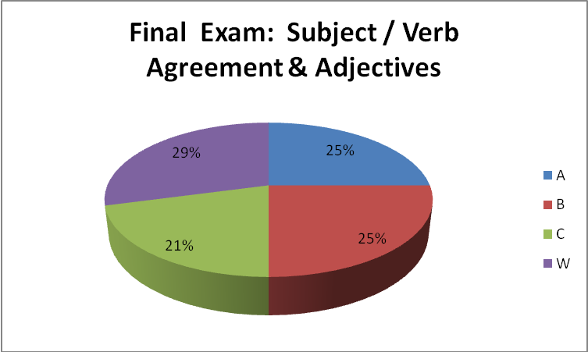
4a. Course/Program Improvements  Please describe what change(s) you plan to implement based on the above results  4b. Will this include a change to the curriculum (i.e., course outline)?  Yes  No X |  |  | Create more handouts and make them available on Blackboard so that students can access easier.  The initial assessment of grammar skills showed the skills were poor. I believe that this is due to the fact that most of the students use English as a second language.  Theirs skills improved but most are still struggling with learning English.
5. How did the SLO(s) contribute to student acquisition of the Institutional Learning Outcome(s) (ILOs)?  For example, if ILO #1 (communication skills) was identified as being related to this SLO, then please write a sentence or two supporting the relationship.  IVC’s 5 ILOs:  ILO1 = Communication Skills  ILO2 = Critical Thinking Skills  ILO3 = Personal Responsibility  ILO4 = Information Literacy  ILO5 = Global Awareness |  |  | IL01: Most of the students in this class use English as a second language. This basic grammar course, improves their basic oral and written communication skills.
6. Next Steps  Was the process effective? Will you change the outcome/assessment (e.g., alter the SLO, assessment, faculty discussion process, strategy for providing SLO to students)?  If so, how? |  |  | The process was effective. Next semester I will assess Delivering an organized, well-informed chapter presentation using PowerPoint
7. After Thoughts

Feel free to celebrate, vent, or otherwise discuss the process

For instructions on how to fill out this form, click here:

SLO Cycle Assessment Form Guidelines

Or visit the IVC SLO Website: http://www.imperial.edu/faculty-and-staff/campus-committees/student-learning-outcomes/slo-forms-and-handouts/

