Academic Program Review



|  |  |  |
| --- | --- | --- |
| **ACADEMIC YEAR** | 2013-2014 | Basic Skills  Transfer  Career Technical Education (CTE) |
| **PROGRAM** | Sociology | |
| **DEPARTMENT** | Behavioral and Social Sciences | |
| **DIVISION** | Health and Sciences | |
| **SUBMITTER** | Kevin White, Department Chair | |

**I. INSTITUTIONAL GOALS**

|  |  |
| --- | --- |
| INSTITUTIONAL GOAL  **1** | **INSTITUTIONAL MISSION AND EFFECTIVENESS** – The College will maintain programs and services that focus on the mission of the College supported by data-driven assessments to measure student learning and student success. |
| INSTITUTIONAL GOAL  **2** | **STUDENT LEARNING PROGRAMS AND SERVICES** – The College will maintain instructional programs and services which support student success and the attainment of student educational goals. |
| INSTITUTIONAL GOAL  **3** | **RESOURCES** – The College will develop and manage human, technological, physical, and financial resources to effectively support the College mission and the campus learning environment. |
| INSTITUTIONAL GOAL  **4** | **LEADERSHIP AND GOVERNANCE** – The Board of Trustees and the Superintendent/President will establish policies that assure the quality, integrity, and effectiveness of student learning programs and services, and the financial stability of the institution. |

**II. PROGRAM GOALS**

1. **PAST – EVALUATION OF PREVIOUS CYCLE OBJECTIVES/PROGRAM GOALS (SET IN PREVIOUS YEAR)**

List your previous objectives/goals and associated Institutional Goals. All program goals must address at least one of the institutional goals.

|  |  |  |  |  |  |
| --- | --- | --- | --- | --- | --- |
| **PAST PROGRAM GOALS**  (Describe past program goals.) | | | | | **INSTITUTIONAL**  **GOAL(S)**  (Check all that apply.) |
|  | |  | | |  |
| **1** | **PAST PROGRAM GOAL #1** | | | | **INSTITUTIONAL GOAL(S)** |
| **Identify Program Goal from Last Program Review:** Transition and implement the new TMC—now the ADT—Associate Degree for Transfer. | | | | 1  2  3  4 |
| Met | | Partially Met | Not Met |
| **Provide detail on any improvements/effectiveness and detail status on those not fully met:** The degree is now listed in the catalog. | | | |
|  |  | | | |  |

|  |  |  |  |  |
| --- | --- | --- | --- | --- |
| **2** | **PAST PROGRAM GOAL #2** | | | **INSTITUTIONAL GOAL(S)** |
| **Identify Program Goal from Last Program Review:** Expand the Media Resource Library and provide access to the Campus and community organizations. | | | 1  2  3  4 |
| Met | Partially Met | Not Met |
| **Provide detail on any improvements/effectiveness and detail status on those not fully met:**  More video resources were added to the Media Library and a software program was purchased to better organize and upgrade the media management. This software is being implemented. The cataloging process is underway. A catalog of our media library will be made available to our Campus and community organizations featuring links to its location on the IVC website. Currently some media is shared with the Campus and community. | | |
|  |  | | |  |
| **3** | **PAST PROGRAM GOAL #3** | | | **INSTITUTIONAL GOAL(S)** |
| **Identify Program Goal from Last Program Review:** Establish a social science statistics course. | | | 1  2  3  4 |
| Met | Partially Met | Not Met |
| **Provide detail on any improvements/effectiveness and detail status on those not fully met:** | | |

**Comments**: The establishment of the SSPS statistical research program is the culmination of a long process that allows IVC to provide students with a state-of-the-art statistics and research course. This course is well-aligned with the new ADT and offers students more options for statistical research. The establishment of this program involved extensive collaboration between many Campus stakeholders. Instruction, Math and Science (resources), IT and Technology Departments (computers), the labs on campus (access), and working together created a course that will benefit students and further student success.

1. **PRESENT – DATA ANALYSIS AND PROGRAM HEALTH**
2. Summarize and analyze all disaggregated data by day, evening, gender, ethnicity, and distance education regarding enrollments, fill rates, productivity, completion, success, retention, persistence, and transfer (complete a, b, & c). ***Attach graphs or trend data***.
3. Discuss and chart the trends in enrollment and fill rate for each program by day and evening at the program level.

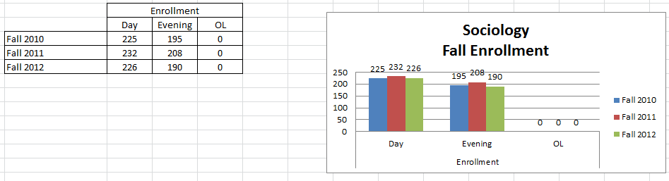

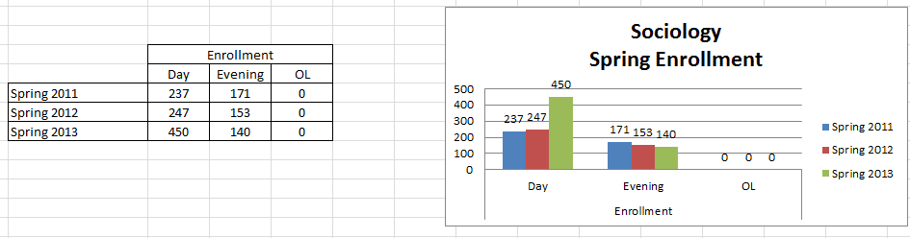

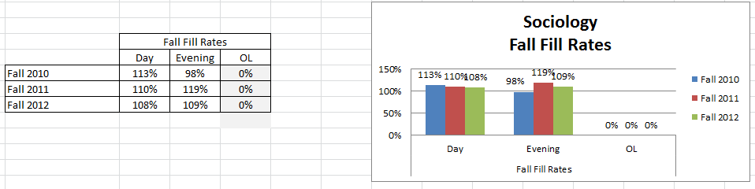

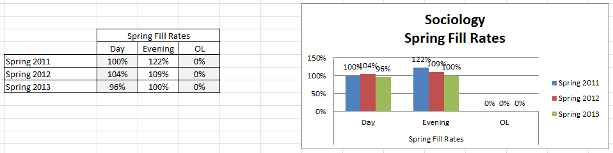

**Enrollments** for Fall Day and Evening classes remained remarkably consistent with only slight variations.  
Enrollments for Spring Day and Evening classes also remain stable with a slight decline in the Evening classes. But Spring 2013 Day enrollment nearly doubled which is a good indication that Sociology is regaining some momentum. No Online classes were offered.  
**Fill Rates** for Fall dropped slightly from 113% to 108%. Historically high fill rates have dipped for the Day but the Evening remains strong. Spring did not fare as well, over the period, it dropped each semester. Changes in enrollment management and scheduling, coupled with loss of campus-wide instruction space and a deep drop in the student population has impacted fill rates.

1. What are the trends in productivity? (WSCH/FTEF) The goal is 525 as per state guidelines. A low number means that we are below target levels for productivity. For example, in a small class that has a mandated cap of 15 students, the fill rate may be 100% but the productivity number (WSCH/FTEF) will be very low. A class with a cap of 40 students with a 100% fill rate will have a productivity number close to or above 525.

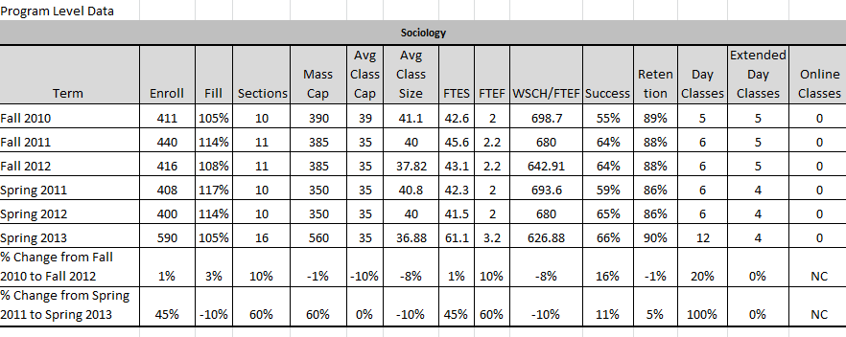

**Comments**: Productivity for all semesters was in the 600s with 626 being the lowest and 698 the highest. There has been an 8% and 10% decrease in Fall and Spring respectively in productivity over the period. Despite the changes in enrollment management, use of block scheduling, and the loss of students over the period, productivity has remained high.

1. Discuss and chart the success and retention rates by day, evening (extended day), and online classes in each program and identify gaps.

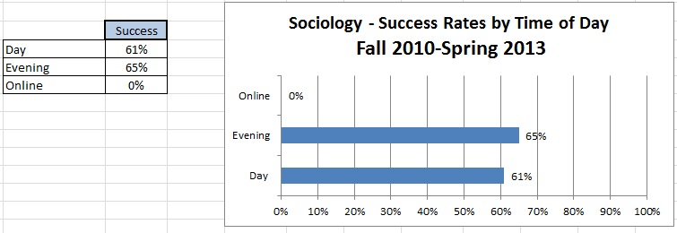

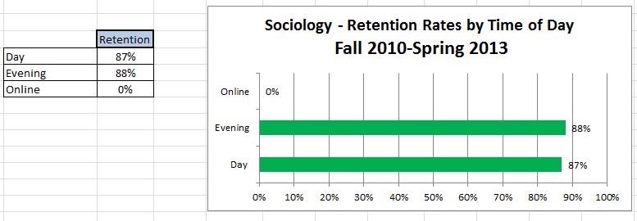

**Comments**: Success and retention rates are higher in the Evening over the review period. Retention rates showed little variation in the Day and Evening yet there is a significant gap (over 20%) between success and retention that needs to be reduced in the coming semesters. These rates, in both success and retention are well within the benchmarks set by IVC.

1. Discuss and chart the success and retention rates in each program and identify gaps for five ethnic groups. (African-American, White, all Hispanics, Other, Unknown).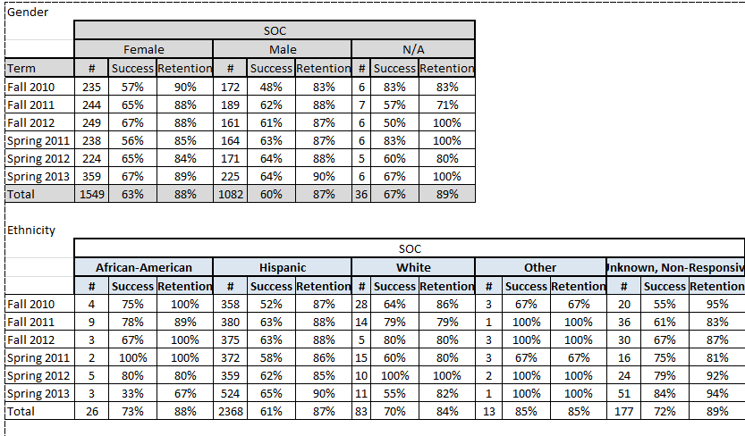

**Gender**: Females continue to earn higher success and retention rates than males, which is a nation-wide trend.

**Ethnicity**: The percentages can be misleading when considered alone, in this case, African Americans ranked the highest (73%) in success followed by White (70%) and Hispanic (61%). Other ranked the highest overall with 85% although it’s not clear who this group represents.

1. Discuss the trends in the number of degrees or certificates awarded, if applicable. (You may be able to expand more about this in B.3 below.)

|  |  |  |  |  |  |  |  |
| --- | --- | --- | --- | --- | --- | --- | --- |
| **Program Completion** |  |  |  |  |  |  |  |
| **Number of Degrees and Certificates Awarded 2010-2011 through 2012-2013 (3 years)** | | | | | | | |
|  |  |  |  |  |  |  |  |
| **Degrees** | **Awarded** |  | **Certificates** | | | **Awarded** |  |
| AAT - Sociology | 6 |  | N/A | | | N/A |  |

This is one of the major challenges facing this discipline. By contrast to the 6 awarded, Psychology posted 139 degrees awarded over the same period of time. Better marketing strategies for marketing this degree needs to be formulated and implemented. It is anticipated that the new, streamlined degree will attract more students to the major.

1. What program changes, if any, will you recommend that you expect would have a positive effect on your students in your program, if applicable?

**Comments**: More degrees conferred—recruit faculty and academic counselors to promote the major. Offer students more delivery methods including web-enhanced, hybrid, and fully online classes. Working more closely with part-time faculty and providing them with the resources they need to stay current and implement institutional and Department policies is becoming more critical, especially as the Community College system moves more toward performance based funding. We have offered more double and in some cases triple loaded classes to maximize efficiencies and improve enrollment management.

1. Summarize revisions, additions, deletions, or alternate delivery methods to courses and/or program based on the last program review.

**Comments**: The vast majority of courses continue to be taught in a face-to-face format. Adding Blackboard has provided faculty with additional options for utilizing technology in and out of the classroom. We are expanding the development of online classes and will begin implementing courses that have completed the new review process as early as Summer 2014. Each planned semester after that will include more Distance Education options including hybrid and online formats.

1. Evaluate the program’s viability by addressing program completion, size (FTES), projections (growing/stable/declining), and quality of outcomes. For CTE programs, also include labor market projections, placement, and performance on external testing/exams (i.e. ASE, NABCEP) and industry-recognized credentials, placement, and performance on external testing or exams (NCLEX, ASC, NAP).

**Comments**: Sociology is a stable and growing program. Its viability is apparent in the success and retention rates generated by this program. Developing and adding more innovative technology—Blackboard, web-enhanced, hybrid, and online is key to its continued improvement. As stated earlier, improving and documenting completions (degrees conferred) is a major challenge going forward.

With minimal staffing, the recent faculty turnovers in this program, and the challenges the College has been facing, Sociology remains a dynamic program.

**C. FUTURE – LIST OF “SMART” (SPECIFIC** **MEASURABLE ATTAINABLE RELEVANT** **TIME-LIMITED) PROGRAM OBJECTIVES FOR NEXT ACADEMIC YEAR TO ADDRESS PROGRAM IMPROVEMENT, GROWTH, OR UNMET NEEDS/GOALS. ALL PROGRAM GOALS MUST ADDRESS AT LEAST ONE OF THE INSTITUTIONAL GOALS.**

|  |  |  |  |  |  |
| --- | --- | --- | --- | --- | --- |
| **FUTURE PROGRAM GOALS**  (Describe future program goals. List in order of budget priority.) | | | | | **INSTITUTIONAL GOAL(S)**  (Check all that apply.) |
|  | | | | |  |
| **1** | **FUTURE PROGRAM GOAL #1**  Budget Priority #1 | | | | **INSTITUTIONAL GOAL(S)** |
| **Identify Goal:** Hire a full-time tenured track instructor to replace the recently hired full-time tenured instructor who resigned at the end of last year | | | | | 1  2  3  4 |
| **Objective:** Replace the temporary full-time instructor | | | | |
| **Task(s):** Advertise, screen, interview, and select new instructor. | | | | |
| **Timeline:** Academic year 2013-14 | | | | |
| **EXPENSE TYPE** | | **FUNDING TYPE** | | **RESOURCE PLAN**  (Check all that apply.) | **BUDGET REQUEST** |
| One-Time  Recurring | | Categorical  Specify: | General Fund | Facilities  Marketing  Technology  Professional Development  Staffing | $80,000 |
|  | | | | |  |

|  |  |  |  |  |  |
| --- | --- | --- | --- | --- | --- |
| **2** | **FUTURE PROGRAM GOAL #2**  Budget Priority #2 | | | | **INSTITUTIONAL GOAL(S)** |
| **Identify Goal:** Align the new ADT with course offerings. | | | | | 1  2  3  4 |
| **Objective:** Streamline the degree course offerings | | | | |
| **Task(s):** Reassess, deactivate and/or delete courses in the major | | | | |
| **Timeline:** Academic year | | | | |
| **EXPENSE TYPE** | | **FUNDING TYPE** | | **RESOURCE PLAN**  (Check all that apply.) | **BUDGET REQUEST** |
| One-Time  Recurring | | Categorical  Specify: | General Fund | Facilities  Marketing  Technology  Professional Development  Staffing | $0 |

|  |  |  |  |  |  |
| --- | --- | --- | --- | --- | --- |
| **3** | **FUTURE PROGRAM GOAL #3**  Budget Priority #3 | | | | **INSTITUTIONAL GOAL(S)** |
| **Identify Goal:** Create more delivery options, including web-enhanced, hybrid, and online classes | | | | | 1  2  3  4 |
| **Objective:** Greater utilization of Blackboard teaching platform | | | | |
| **Task(s):** Provide training and encouragement for faculty to utilize Blackboard | | | | |
| **Timeline:** Academic year | | | | |
| **EXPENSE TYPE** | | **FUNDING TYPE** | | **RESOURCE PLAN**  (Check all that apply.) | **BUDGET REQUEST** |
| One-Time  Recurring | | Categorical  Specify: | General Fund | Facilities  Marketing  Technology  Professional Development  Staffing | $0 |
|  | | | | |  |
| **TOTAL BUDGET REQUEST** | | | | | $80,000 |

1. How will your enhanced budget request improve student success?

Replacing a recently departed full-time tenured track instructor will only keep things status quo for a while. At some point in the near future we will need an additional faculty member to cover the high demand classes.

**III. INSTITUTIONAL STUDENT LEARNING OUTCOMES (ISLOs)**

|  |  |
| --- | --- |
| **ISLO 1** | COMMUNICATION SKILLS |
| **ISLO 2** | CRITICAL THINKING SKILLS |
| **ISLO 3** | PERSONAL RESPONSIBILITY |
| **ISLO 4** | INFORMATION LITERACY |
| **ISLO 5** | GLOBAL AWARENESS |

**IV. PROGRAM LEARNING OUTCOMES (PLOs)**

|  |  |  |  |  |
| --- | --- | --- | --- | --- |
| **PROGRAM LEARNING OUTCOMES**  (Describe learning outcomes.) | | | | **ISLO(S)**  [Link PLO to  appropriate ISLO(s).] |
|  |  | | |  |
| **PLO**  **1** | **PROGRAM LEARNING OUTCOME #1** | | | **ISLO(S)** |
| **Identify Program Outcome:** Demonstrate an understanding of how social structures (families, schools, churches, laws) influence day to day experiences of individuals. | | | ISLO 1  ISLO 2  ISLO 3  ISLO 4  ISLO 5 |
| **Measurable Outcome Summary:** | | |
| Met | Partially Met | Not Met |
| **Provide detail on any improvements/effectiveness and detail status on those not fully met:** | | |
|  |  | | |  |

|  |  |  |  |  |
| --- | --- | --- | --- | --- |
| **PLO**  **2** | **PROGRAM LEARNING OUTCOME #2** | | | **ISLO(S)** |
| **Identify Program Outcome:** Demonstrate the ability to find information, assess evidence and evaluate arguments in empirical studies. | | | ISLO 1  ISLO 2  ISLO 3  ISLO 4  ISLO 5 |
| **Measurable Outcome Summary:** | | |
| Met | Partially Met | Not Met |
| **Provide detail on any improvements/effectiveness and detail status on those not fully met:** | | |
|  |  | | |  |
| **PLO**  **3** | **PROGRAM LEARNING OUTCOME #3** | | | **ISLO(S)** |
| **Identify Program Outcome:** Apply sociological theory and analysis to major social problems involving individuals, groups, cultures, and society. | | | ISLO 1  ISLO 2  ISLO 3  ISLO 4  ISLO 5 |
| **Measurable Outcome Summary:** | | |
| Met | Partially Met | Not Met |
| **Provide detail on any improvements/effectiveness and detail status on those not fully met:** | | |
|  |  | | |  |
| **\*\*\*\*\* ATTACH PLO/SLO GRID \*\*\*\*\*** | | | | |

