SLO Cycle Assessment Form
Please type on this form. Do not submit handwritten forms.

Course:  Computer Acctg: CIS 108 |  | Semester data collected:  Fall 2012 |  | Date this form was completed:  December 12, 2012
# of sections offered:  1 | # of sections assessed:  1 |  | Data Collected from: (Check all that apply)  FT Faculty __X____ PT Faculty ______  Day ___X___ Evening _____ Hybrid/Online_____ Weekend______
1. People involved in summarizing & evaluating data (minimum of two) |  |  | Vicki Viloria  Craig Blek
2. Please list the SLO(s) that was (were) assessed. Include the description listed on the Course Record of Outline. |  |  | Apply accounting theories to analyze a transaction, choose an appropriate financial document, and correctly enter a transaction using a business accounting software package.
3. Data results  Briefly summarize the data. (Please see instructions). |  |  | Used Final Exam to evaluate. See Chart Below: 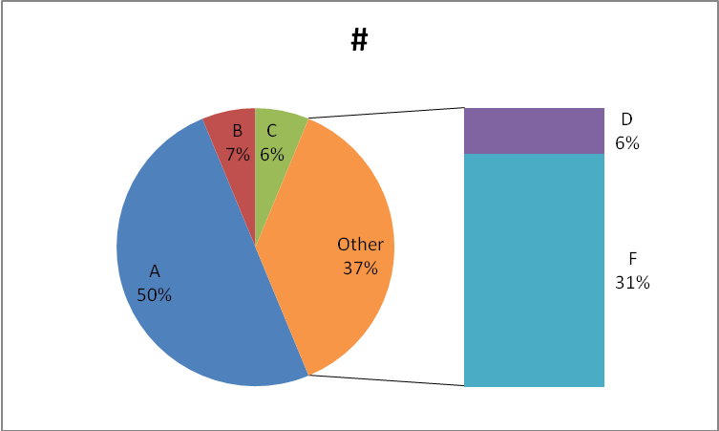
4a. Course/Program Improvements  Please describe what change(s) you plan to implement based on the above results  4b. Will this include a change to the curriculum (i.e., course outline)?  Yes  No X |  |  | This semester had a rough start because the software was not available on the computers for the first two and half weeks of the semester.  The software needs to be available on day one so that the students achieve success earlier in the semester.
5. How did the SLO(s) contribute to student acquisition of the Institutional Learning Outcome(s) (ILOs)?  For example, if ILO #1 (communication skills) was identified as being related to this SLO, then please write a sentence or two supporting the relationship.  IVC’s 5 ILOs:  ILO1 = Communication Skills  ILO2 = Critical Thinking Skills  ILO3 = Personal Responsibility  ILO4 = Information Literacy  ILO5 = Global Awareness |  |  | ILO2: Students first learned how to record accounting transactions by using step by step instructions. Then, the student applied the skills learned in the end of chapter problems, practice sets, and the comprehensive practice set without any additional instruction.
6. Next Steps  Was the process effective? Will you change the outcome/assessment (e.g., alter the SLO, assessment, faculty discussion process, strategy for providing SLO to students)?  If so, how? |  |  | The process was effective.  Next semester I will focus on the SLO to Print and analyze financial statements for inconsistencies and revise as necessary.
7. After Thoughts

Feel free to celebrate, vent, or otherwise discuss the process

For instructions on how to fill out this form, click here:

SLO Cycle Assessment Form Guidelines

Or visit the IVC SLO Website: http://www.imperial.edu/faculty-and-staff/campus-committees/student-learning-outcomes/slo-forms-and-handouts/

