SLO Cycle Assessment Form

1. Course Number &  Date form was completed | Course:  BIOL 180 | Date: 9/11/12
2. People involved in summarizing & evaluating data (minimum of two) | Daniel Gilison  Tom Morrell
3. Semester data was collected (e.g., Spring 2011) | Fall 2011
4. Please list the SLO(s) that was (were) assessed. Write it out. | Discuss primary research literature and understand how science is performed and described. (ILO4)
5. Data results  Briefly summarize the results of the data. | Four times throughout the semester, students were given primary literature to read. There were two parts to the graded assessment – a 5-question multiple choice quiz (5 points), and a group discussion session (15 points). The quiz allowed the students to demonstrate their knowledge of the content of the journal article (quizzes were “open article”) and the format of journal articles. The discussion topics were given out one week in advance, along with the article, and then one question was randomly assigned to each student group. Students would then discuss their answers during class. Answers would be questioned by me, and students in other groups had the opportunity to give their thoughts.  Due to the difficult nature of understanding fully these journal articles, student groups were given multiple opportunities to properly answer their discussion questions, and grading was relatively lenient.  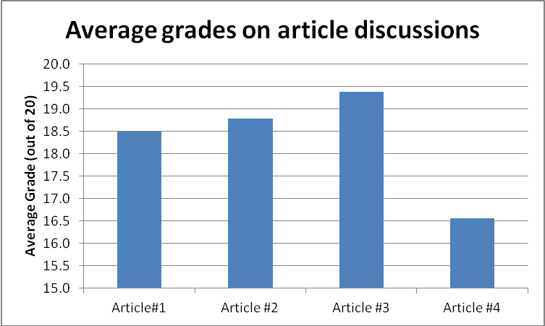  As the data shows, the average score for each assignment was between a 18.5 and 19.5 out of 20, with the exception of the fourth asignment, which had an average score of 16.5 out of 20, mainly because one group had difficulty answering one of the discussion questions.
6a. Course/Program Improvements  Please describe what change(s) you plan to implement based on the above results  6b. Will this include a change to the curriculum (i.e., course outline)?  Yes  No X | While it would be nice to see how each student can answer these discussion questions, I think that it’s more comfortable for the students to attempt to discuss these challenging journal articles in groups.  I give the discussion topics to the students a week in advance to allow them to prepare for all of the questions, and then they get assigned one of the six questions for the graded assignment.  The overall purpose of these assignments is to get students exposed to primary, peer-reviewed scientific literature, which will help them in future courses, and help them write lab reports in this course.
7. When SLOs were previously written, Institutional Learning Outcomes (ILOs) were identified as part of that process.  How did the SLO(s) contribute to student acquisition of the Institutional Learning Outcome(s) (ILOs)?  For example, if ILO #1 (communication skills) was identified as being related to this SLO, then please write a sentence or two supporting the relationship.  IVC’s 5 ILOs:  ILO1 = Communication Skills  ILO2 = Critical Thinking Skills  ILO3 = Personal Responsibility  ILO4 = Information Literacy  ILO5 = Global Awareness | The ILO examined for this SLO is ILO4, Information Literacy. By having students read primary scientific literature, they are being exposed to information that they would not normally get from traditionally available sources.
8. Next year  Was the process effective? Will you change the outcome/assessment (e.g., alter the SLO, assessment, faculty discussion process, strategy for providing SLO to students)?  If so, how? | This is the first time assessing this specific SLO, so I will have to address this question again next time.
9. After Thoughts

Feel free to celebrate, vent, or otherwise discuss the process

The SLO Cycle Assessment Form Guidelines

1. Please list the course number and date that cycle assessment form was completed.

2. To encourage collaboration and the sharing of ideas, each form must be completed by at least two people. If you are the only one teaching the course, you are encourage to share your data results and improvement methods with at least one other member of the faculty, administration, staff or student population. Please list the names of all who were involved in summarizing or evaluating the data.

3. Include the semester when the data was included (e.g., Spring 2011).

4. List the SLO(s) that was (were) assessed (e.g., “identify, create, and critique oral argument”).

5. Please summarize the data that you collected. Include how well students scored on the assessment. You might also include: how many instructors submitted data (fulltime, parttime); the type of data that was submitted (rubric scores, practical test results, etc); and, as appropriate, if a cross-section of classes (day, evening, online) were assessed. For example, if a rubric was used, you might discuss the number of students who scored 1, 2, 3, or 4, on the rubric. Your original data results, or your raw data, should be kept within your department for three years.

6a. This is an opportunity to have a rich discussion with others involved in education. Please describe any changes that will be implemented based on the data. Changes might be made to class activities, assignment instructions, evaluations, topics taught in class, or the course outline of record, etc. You might include when the changes will be implemented and, if a comparison is to be made, when the next round of data will be collected (e.g., Fall 2012).

6b. Answer “Yes” or “No” to the curriculum question – if yes, please briefly explain.

7. This recently added section is very important because it allows us to document different ways that students are acquiring the 5 ILOs. We state that “Upon completion of a degree, program, or certificate, a student will complete coursework at Imperial Valley College demonstrating competency in communicating skills, critical thinking skills, personal responsibility, information literacy, and global awareness.” We need to demonstrate that this is occurring. Please refer to the “Strive for Five” form for more of an in-depth description of ILOs.

8. This provides an opportunity to discuss what went well and what could be improved. If the SLO needs to be tweaked or more outcomes/assessments need to be included you might want to do that now while the information is fresh. This may allow faculty to modify SLO(s) for next year and include them on next year’s syllabus.

9. Please share your thoughts, feelings, and ideas on IVC’s SLO process thus far.

/tmp/in/input.doc

