SLO Cycle Assessment Form

1. Course Number &  Date form was completed | Course:  BIOL 180 | Date: 6/6/11
2. People involved in summarizing & evaluating data (minimum of two) | Daniel Gilison  Tom Morrell
3. Semester data was collected (e.g., Spring 2011) | Fall 2010
4. Please list the SLO(s) that was (were) assessed. Write it out. | Demonstrate the ability to think like a scientist by coming up with a valid experimental design. (ILO 2)
5. Data results  Briefly summarize the results of the data. | 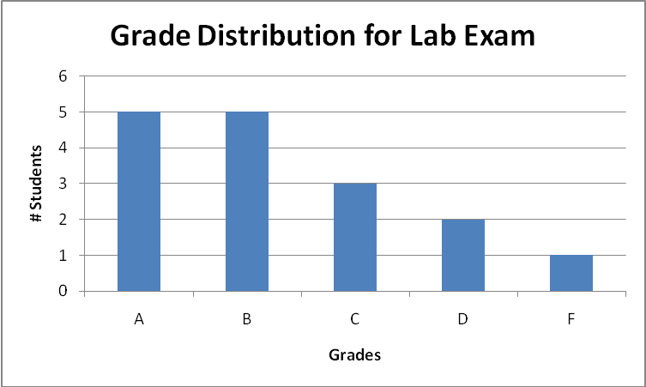  Students were given a 3-hour final written lab exam where they were supposed to read a short paragraph of information, come up with a hypothesis to test, design an experiment that would test that hypothesis, and show data that would either support or reject their hypothesis.  There were 16 students who took the final, and the grade distribution is shown above. Please note that the student who got an F on the exam did not show up to take the test. Overall, the students did very well on the exam, with only 2 Ds and 1, and averaging a 78.4%.  From observing the students while taking the exam, and answering questions during the exam, I noticed that the most difficult aspect of the exam was coming up with the hypothesis. It appeared that once students did come up with a hypothesis, they were able to complete the rest of the exam in about 30 minutes or so, but some took up to two hours to come up with a one-sentence hypothesis for their exam.
6a. Course/Program Improvements  Please describe what change(s) you plan to implement based on the above results  6b. Will this include a change to the curriculum (i.e., course outline)?  Yes  No X | I don’t think that I need to change the curriculum for this course, but perhaps I need to spend more time on hypothesis generation and helping students understand how to best come up with a hypothesis that can be tested. Part of the problem during the exam was that students were coming up with hypotheses that were too complicated, and had difficulty coming up with experiments to test them. Once they were able to simplify their hypotheses, they were able to quickly finish the rest of the exam.  So, I could give an assignment early in the semester to ask them to generate a hypothesis based on some scientific knowledge, or perhaps to work through how scientists came up with their hypotheses when reading primary scientific literature.
7. When SLOs were previously written, Institutional Learning Outcomes (ILOs) were identified as part of that process.  How did the SLO(s) contribute to student acquisition of the Institutional Learning Outcome(s) (ILOs)?  For example, if ILO #1 (communication skills) was identified as being related to this SLO, then please write a sentence or two supporting the relationship.  IVC’s 5 ILOs:  ILO1 = Communication Skills  ILO2 = Critical Thinking Skills  ILO3 = Personal Responsibility  ILO4 = Information Literacy  ILO5 = Global Awareness | The ILO being examined here was ILO2, Critical Thinking Skills. This SLO contributed to the student acquisition of critical thinking skills because the lab final exam required the students to come up with their own hypothesis, and then come up with their own experiment that would test their hypothesis. Therefore, there could be multiple correct answers on the exam, simply based on how each individual student thought about how to approach the question.
8. Next year  Was the process effective? Will you change the outcome/assessment (e.g., alter the SLO, assessment, faculty discussion process, strategy for providing SLO to students)?  If so, how? | This is the first time assessing this specific SLO, so I will have to address this question again next time.
9. After Thoughts

Feel free to celebrate, vent, or otherwise discuss the process

The SLO Cycle Assessment Form Guidelines

1. Please list the course number and date that cycle assessment form was completed.

2. To encourage collaboration and the sharing of ideas, each form must be completed by at least two people. If you are the only one teaching the course, you are encourage to share your data results and improvement methods with at least one other member of the faculty, administration, staff or student population. Please list the names of all who were involved in summarizing or evaluating the data.

3. Include the semester when the data was included (e.g., Spring 2011).

4. List the SLO(s) that was (were) assessed (e.g., “identify, create, and critique oral argument”).

5. Please summarize the data that you collected. Include how well students scored on the assessment. You might also include: how many instructors submitted data (fulltime, parttime); the type of data that was submitted (rubric scores, practical test results, etc); and, as appropriate, if a cross-section of classes (day, evening, online) were assessed. For example, if a rubric was used, you might discuss the number of students who scored 1, 2, 3, or 4, on the rubric. Your original data results, or your raw data, should be kept within your department for three years.

6a. This is an opportunity to have a rich discussion with others involved in education. Please describe any changes that will be implemented based on the data. Changes might be made to class activities, assignment instructions, evaluations, topics taught in class, or the course outline of record, etc. You might include when the changes will be implemented and, if a comparison is to be made, when the next round of data will be collected (e.g., Fall 2012).

6b. Answer “Yes” or “No” to the curriculum question – if yes, please briefly explain.

7. This recently added section is very important because it allows us to document different ways that students are acquiring the 5 ILOs. We state that “Upon completion of a degree, program, or certificate, a student will complete coursework at Imperial Valley College demonstrating competency in communicating skills, critical thinking skills, personal responsibility, information literacy, and global awareness.” We need to demonstrate that this is occurring. Please refer to the “Strive for Five” form for more of an in-depth description of ILOs.

8. This provides an opportunity to discuss what went well and what could be improved. If the SLO needs to be tweaked or more outcomes/assessments need to be included you might want to do that now while the information is fresh. This may allow faculty to modify SLO(s) for next year and include them on next year’s syllabus.

9. Please share your thoughts, feelings, and ideas on IVC’s SLO process thus far.

/tmp/in/input.doc

