IMPERIAL VALLEY COLLEGE
Student Learning Outcomes (SLO) Identification Form & Assessment Cycle

Department Name: | Science, Math, and Engineering

Course Number/Title or Program Title: | BIOL150 – Human Genetics

Contact Person/Others Involved in Process: | Lead: Daniel Gilison Others: Tom Morrell

If course is part of a major(s), and/or certificate program(s), please list all below:

Major(s): | Certificate(s):
General Science
Life Science
University Studies

Does course satisfy a community college GE requirement(s)? | X | Yes |  | No |  | N/A
If yes, check which requirement(s) below:

 |  | American Institutions |  | Language and Rationality – English Composition
 |  | Health Education |  | Language and Rationality – Communication and Analytical Thinking
 |  | Physical Education / Activity | X | Natural Science
 |  | Math Competency |  | Humanities
 |  | Reading Competency |  | Social and Behavioral Sciences
 | Student Learning Outcome |  |  |  | Assessment Tool  (e.g., exam, rubric, portfolio) | Institutional Outcome*  (e.g., ISLO1, ISLO2)
 | Answer exam questions that deal with population genetics. |  |  |  | Short-answer exam questions | ISLO5
 | Show personal responsibility by turning in homework assignments in on time. |  |  |  | N/A | ISLO3
 | Answer exam questions that deal with critical thinking problem solving. |  |  |  | Short-answer exam questions | ISLO2
Each SLO should describe the knowledge, skills, and/or abilities students will have after successful
completion of course or as a result of participation in activity/program. A minimum of one SLO is required
per course/program. You may identify more than one SLO, but please note that you will need to collect and
evaluate data for each SLO that you list above. Attach separate pages if needed. For assistance contact: Toni Pfister toni.pfister@imperial.edu or X6546

*Institutional Student Learning Outcomes: ISLO1 = communication skills; ISLO2 = critical thinking skills;
ISLO3 = personal responsibility; ISLO4 = information literacy; ISLO5 = global awareness

1. Course Number | BIOL150 – Human Genetics
2. People involved in summarizing and evaluating data | Daniel Gilison
3. Data Results  Briefly summarize the results of the data you collected. | 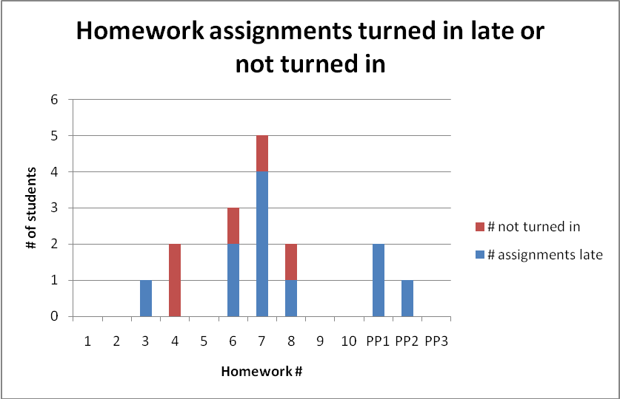  For this class, there were 13 take-home assignments that the students had to complete and turn in. 10 of them were 20-point homework assignments, and 3 of them (PP1-3) were 5-point extra credit assignments, which were just smaller versions of homework assignments. The students had one week to turn in each assignment. I told the students at the beginning of the semester that I would give them 1 “mulligan” – they could turn in one assignment late without any penalty, but after that, any late assignment would get a 0.  This data shows that most late assignments occurred during the middle of the semester. Only one student turned in two late assignments, and got no credit for that extra credit assignment. Overall, out of 22 students who made it to the end of the semester, very few students turned in late assignments (4 total), and very few assignments were turned in late or not at all.
4. Course / Program Improvement  Please describe what change(s) you plan to implement based on the above results. | Based on the above data, I am actually very happy with the timing of the assignments that were turned in. I told the students that I do realize that things happen that could cause them to be late to class, so giving them the “mulligan” allows for life to intrude in the class, but only once. Students did not constantly turn in assignments late, or not at all, so they did realize the importance of the homework.  **Will this include a change to the curriculum (i.e. course outline)? No.
5. Next Year (Optional) Was the process effective? Will you change the outcome/ assessment for next year? (e.g., alter the SLO, assessment, faculty discussion process, strategy for providing SLO to student)? If so, how?
6. After-Thoughts (optional) Feel free to celebrate, vent, or otherwise discuss the process.

The ASSESSMENT CYCLE: Closing the Assessment Loop
You may elaborate as much as you need to in order to complete this form. Instructions are on the following page.

- Please list the course number. In case page 1 is separated from page 2, this will help with
organization.

- To encourage collaboration and the sharing of ideas, each form must be completed by at least
two people. If you are the only one teaching the course, you are encourage to share your data
results and improvement methods with at least one other staff or faculty member. Please list
the names of all faculty, staff, and students who were involved in summarizing or evaluating
the data. These names may be the same or different than those on the original SLO ID form.

- Your original data results, or your raw data, should be kept within your department for three
years. At this time you do not need to submit the raw data, but please keep it for future quality
control measures. Please summarize the data that you collected. You should include how well
students scored on the assessment. You might also include: how many instructors submitted
data(full-time, part-time); the type of data that was submitted (rubric scores, practical test
results, etc); and, if appropriate, if a cross-section of classes (day, evening, online) were
assessed. If a rubric was used, you might discuss the number of students who scored 1, 2, 3,
or 4, for example, on the rubric.

- This is an opportunity to have a rich discussion with others involved in education. Please
describe any changes that can be made based on the data. Changes might be made to class
activities, assignment instructions, topics taught in class, or the course outline of record, etc.
You might include when the changes will be implemented and, if a comparison is to be made,
when the next round of data will be collected (e.g. Fall 2009).

Then, answer “Yes” or “No” to the curriculum question – no explanations required but please
answer the question.

- This is optional but may provide an opportunity to discuss what went well and what could be
improved. If the SLO needs to be tweaked or more outcomes/assessments need to be included
you might want to do that now while the information is fresh. This may allow faculty to have
SLO(s) completed early and included on next year’s syllabus.

- This is another optional question. Please share your thoughts, feelings, and ideas on IVC’s
SLO process thus far.

When completed, please email this form to your division secretary or chair (whoever is managing it locally) AND send a hard paper copy to the SLO coordinator. Thanks.

