Academic Program Review



|  |  |  |
| --- | --- | --- |
| **ACADEMIC YEAR** | 2013-2014 | Basic Skills  Transfer  Career Technical Education (CTE) |
| **PROGRAM** | Psychology | |
| **DEPARTMENT** | Behavioral and Social Sciences | |
| **DIVISION** | Health and Sciences | |
| **SUBMITTER** | Kevin White, Department Chair | |

**I. INSTITUTIONAL GOALS**

|  |  |
| --- | --- |
| INSTITUTIONAL GOAL  **1** | **INSTITUTIONAL MISSION AND EFFECTIVENESS** – The College will maintain programs and services that focus on the mission of the College supported by data-driven assessments to measure student learning and student success. |
| INSTITUTIONAL GOAL  **2** | **STUDENT LEARNING PROGRAMS AND SERVICES** – The College will maintain instructional programs and services which support student success and the attainment of student educational goals. |
| INSTITUTIONAL GOAL  **3** | **RESOURCES** – The College will develop and manage human, technological, physical, and financial resources to effectively support the College mission and the campus learning environment. |
| INSTITUTIONAL GOAL  **4** | **LEADERSHIP AND GOVERNANCE** – The Board of Trustees and the Superintendent/President will establish policies that assure the quality, integrity, and effectiveness of student learning programs and services, and the financial stability of the institution. |

**II. PROGRAM GOALS**

1. **PAST – EVALUATION OF PREVIOUS CYCLE OBJECTIVES/PROGRAM GOALS (SET IN PREVIOUS YEAR)**

List your previous objectives/goals and associated Institutional Goals. All program goals must address at least one of the institutional goals.

|  |  |  |  |  |  |
| --- | --- | --- | --- | --- | --- |
| **PAST PROGRAM GOALS**  (Describe past program goals.) | | | | | **INSTITUTIONAL**  **GOAL(S)**  (Check all that apply.) |
|  | |  | | |  |
| **1** | **PAST PROGRAM GOAL #1** | | | | **INSTITUTIONAL GOAL(S)** |
| **Identify Program Goal from Last Program Review:** Hire a full-time instructor. | | | | 1  2  3  4 |
| Met | | Partially Met | Not Met |
| **Provide detail on any improvements/effectiveness and detail status on those not fully met:** | | | |
|  |  | | | |  |

|  |  |  |  |  |
| --- | --- | --- | --- | --- |
| **2** | **PAST PROGRAM GOAL #2** | | | **INSTITUTIONAL GOAL(S)** |
| **Identify Program Goal from Last Program Review:** Establish a statistics course | | | 1  2  3  4 |
| Met | Partially Met | Not Met |
| **Provide detail on any improvements/effectiveness and detail status on those not fully met:** | | |
|  |  | | |  |
| **3** | **PAST PROGRAM GOAL #3** | | | **INSTITUTIONAL GOAL(S)** |
| **Identify Program Goal from Last Program Review:** Implement the new Associate Degree for Transfer (ADT) and re-assess course offerings in light of the new ADT. | | | 1  2  3  4 |
| Met | Partially Met | Not Met |
| **Provide detail on any improvements/effectiveness and detail status on those not fully met:** The new ADT is being implemented. This major requires research and statistics as part of its core offering and required working with the established labs on campus (math and language) to offer appropriate space and times. The IT/Technology Department assisted with the delivery of new (refreshment program) computers and helped purchase the SPSS hard/software needed to run the program. | | |

**Comments**: A full-time instructor has been hired replace the tenured-track, instructor who resigned last Spring. However, we have loss three (3) fulltime instructors over the last 7 years and have had to rely on fulltime professors accepting high overloads to meet our high demand courses. Past Program Goal #3 required a lot of cooperation and coordination of services among many campus stakeholders. There were many glitches that had to be overcome. The purchase, set-up, and implementation of the statistics/research equipment has been completed and our students are now engaged in earning credits towards the new degree. A newly developed Program Pathway (2 year guide to graduation) will provide students’ with a clear academic roadmap. This goal impacted all of the College’s institutional goals.

1. **PRESENT – DATA ANALYSIS AND PROGRAM HEALTH**
2. Summarize and analyze all disaggregated data by day, evening, gender, ethnicity, and distance education regarding enrollments, fill rates, productivity, completion, success, retention, persistence, and transfer (complete a, b, & c). ***Attach graphs or trend data***.
3. Discuss and chart the trends in enrollment and fill rate for each program by day and evening at the program level.

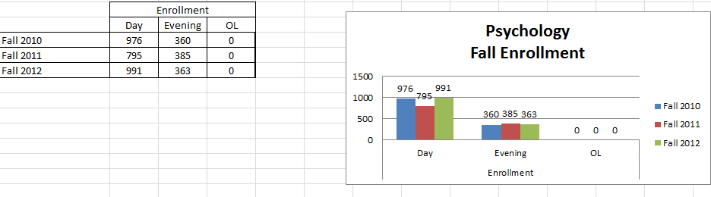

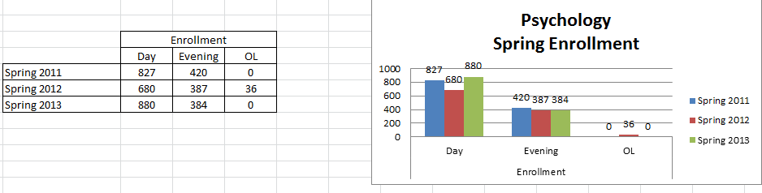

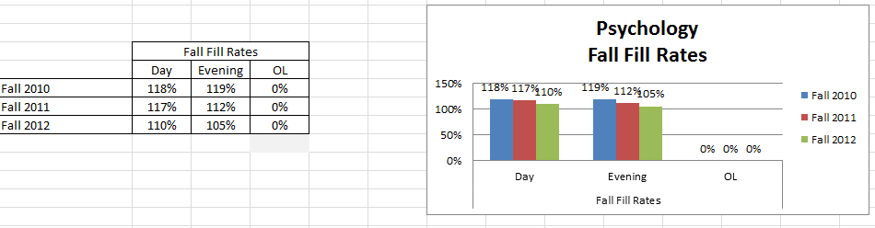

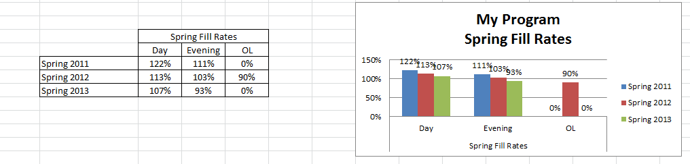

**Comments**: Enrollment dipped in the Fall of 2011 and Spring of 2012, but now Fall of 2012 and Spring of 2013 are the highest of the three year period. Evening enrollment has remained remarkably steady. Fall and Spring Fill rates have dropped from averages hovering around 120% to between 105 and 110 percent. Only Spring 2013’s Evening fill rate dropped below 100% to 93 percent. Overall the enrollment and fill rates remain high given the economic and enrollment management changes that have impacted our Departments’ ability to serve students and facilitate student success.

1. What are the trends in productivity? (WSCH/FTEF) The goal is 525 as per state guidelines. A low number means that we are below target levels for productivity. For example, in a small class that has a mandated cap of 15 students, the fill rate may be 100% but the productivity number (WSCH/FTEF) will be very low. A class with a cap of 40 students with a 100% fill rate will have a productivity number close to or above 525.

|  |  |  |  |  |  |  |  |  |  |  |  |  |  |  |
| --- | --- | --- | --- | --- | --- | --- | --- | --- | --- | --- | --- | --- | --- | --- |
| **Psychology** | | | | | | | | | | | | | | |
|  | Enroll | Fill | Sections | Mass Cap | Avg Class Cap | Avg Class Size | FTES | FTEF | WSCH/FTEF | Success | Retention | Day Classes | Extended Day Classes | Online Classes |
| Fall 2010 | 1336 | 118% | 27 | 1132 | 41.93 | 49.48 | 138.43 | 6 | 758.7 | 71% | 93% | 19 | 8 | 0 |
| Fall 2011 | 1180 | 115% | 26 | 1025 | 39.42 | 45.38 | 122.29 | 5.4 | 746.69 | 71% | 92% | 17 | 9 | 0 |
| Fall 2012 | 1354 | 108% | 29 | 1250 | 43.1 | 46.69 | 140.28 | 6.6 | 706.09 | 75% | 92% | 20 | 9 | 0 |
| Spring 2011 | 1246 | 118% | 27 | 1055 | 39.07 | 46.15 | 129.1 | 5.6 | 762.48 | 72% | 90% | 17 | 10 | 0 |
| Spring 2012 | 1102 | 109% | 26 | 1015 | 39.04 | 42.38 | 114.11 | 5.4 | 696.67 | 69% | 89% | 16 | 10 | 1 |
| Spring 2013 | 1263 | 102% | 30 | 1235 | 41.17 | 42.1 | 130.87 | 6.6 | 652.52 | 64% | 88% | 20 | 10 | 0 |
| % Change from Fall 2010 to Fall 2012 | 1% | -8% | 7% | 10% | 3% | -6% | 1% | 10% | -7% | 5% | -1% | 5% | 13% | NC |
| % Change from Spring 2011 to Spring 2013 | 1% | -14% | 11% | 17% | 5% | -9% | 1% | 18% | -14% | -10% | -2% | 18% | 0% | NC |
|  |  |  |  |  |  |  |  |  |  |  |  |  |  |  |

**Comments**: Productivity has shown a slight but steady drop over the period. All Fall and Spring figures are well above the 525 standard, ranging from 652 to 762. Success, retention, and average class size are slipping in the wrong direction. While the Program Pathway will provide a clear roadmap to graduation, it is unclear at this time whether the new degree requirements—research and statistics—will lower interest in the major.

1. Discuss and chart the success and retention rates by day, evening (extended day), and online classes in each program and identify gaps.

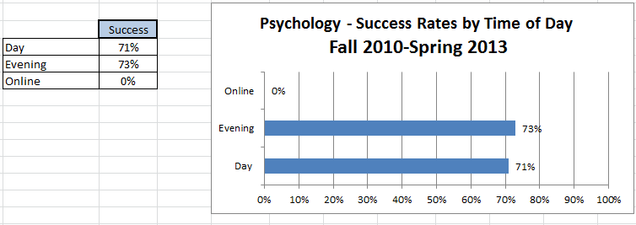

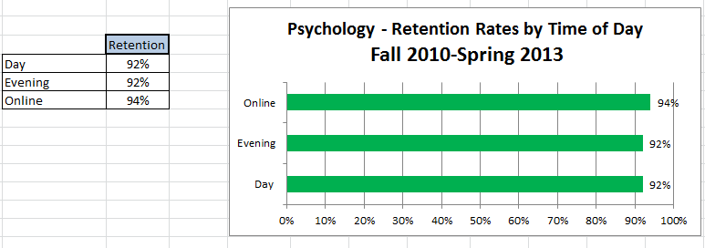

**Comments**: Success and retention by Day and Evening classes are roughly equal. There’s a gap of nearly 20 percent between success and retention. The online percentage is misleading since only one online class was offered during the period. Greater success and retention can be facilitated by more fulltime instructors, vigorous implementation of the new ADT, greater coordination of student services, and better scheduling of high demand classes.

1. Discuss and chart the success and retention rates in each program and identify gaps for five ethnic groups. (African-American, White, all Hispanics, Other, Unknown).

|  |  |  |  |  |  |  |  |  |  |  |  |  |  |  |  |
| --- | --- | --- | --- | --- | --- | --- | --- | --- | --- | --- | --- | --- | --- | --- | --- |
|  | PSY | | | | | | | | | | | | | | |
|  | **African-American** | | | **Hispanic** | | | **White** | | | **Other** | | | **Unknown, Non-Responsive** | | |
|  | **#** | **Success** | **Retention** | **#** | **Success** | **Retention** | **#** | **Success** | **Retention** | **#** | **Success** | **Retention** | **#** | **Success** | **Retention** |
| Fall 2010 | 6 | 67% | 83% | 1203 | 71% | 93% | 59 | 81% | 95% | 14 | 93% | 100% | 54 | 65% | 91% |
| Fall 2011 | 9 | 56% | 100% | 1040 | 70% | 91% | 34 | 76% | 91% | 3 | 100% | 100% | 94 | 82% | 96% |
| Fall 2012 | 5 | 40% | 80% | 1203 | 74% | 92% | 20 | 95% | 100% | 5 | 80% | 80% | 121 | 76% | 94% |
| Spring 2011 | 9 | 89% | 100% | 1087 | 71% | 90% | 55 | 85% | 95% | 14 | 71% | 71% | 82 | 65% | 89% |
| Spring 2012 | 6 | 83% | 100% | 981 | 68% | 89% | 29 | 86% | 86% | 7 | 86% | 86% | 80 | 69% | 89% |
| Spring 2013 | 4 | 50% | 50% | 1138 | 64% | 88% | 21 | 90% | 90% | 3 | 100% | 100% | 98 | 63% | 86% |
| Total | 39 | 67% | 90% | 6652 | 70% | 91% | 218 | 84% | 93% | 46 | 85% | 87% | 529 | 71% | 91% |
|  |  |  |  |  |  |  |  |  |  |  |  |  |  |  |  |

**Comments**: The small number of African-American and Other make comparisons difficult. In general, Whites have the highest success rate with Unknown, Non-responsive second, Hispanic third, and African-American fourth. Retention is high among all groups. The Imperial Valley has some of the lowest high school scores in the state and many of our students are poorly prepared for Community College. More Basic Skills, ESL, and other student-centered supportive services are needed to impact success.

1. Discuss the trends in the number of degrees or certificates awarded, if applicable. (You may be able to expand more about this in B.3 below.)

|  |  |  |  |  |  |  |
| --- | --- | --- | --- | --- | --- | --- |
| **Program Completion** |  |  |  |  |  |  |
| **Number of Degrees and Certificates Awarded 2010-2011 through 2012-2013 (3 years)** | | | | | | |
|  |  |  |  |  |  |  |
| **Degrees** | **Awarded** |  | **Certificates** | | | **Awarded** |
| A.A. Psychology | 139 |  | N/A | | | N/A |

The Psychology major is a very popular. It is the number 2 degree awarded at Imperial Valley College.

1. What program changes, if any, will you recommend that you expect would have a positive effect on your students in your program, if applicable?

**Comments**: Increase the amount of faculty using web-enhanced instruction and Blackboard; fully implement the new Program Pathways, especially seeing it in the IVC Catalog; develop more Distance Education options for students; continue to develop and promote the new transfer degree (ADT), especially the focus on statistics and research; hire more fulltime faculty to spread the load of classes; and create a mentorship program for full and part-time faculty.

1. Summarize revisions, additions, deletions, or alternate delivery methods to courses and/or program based on the last program review.

**Comments**: More faculty are using Blackboard; we are in the process of developing more online offerings; under the new enrollment management system we are offering some basic, introductory courses as double and triple loads provided appropriate room space; and there was not much interest, by Department faculty, in pursuing paired classes with other disciplines to strengthen core outcomes.

1. Evaluate the program’s viability by addressing program completion, size (FTES), projections (growing/stable/declining), and quality of outcomes. For CTE programs, also include labor market projections, placement, and performance on external testing/exams (i.e. ASE, NABCEP) and industry-recognized credentials, placement, and performance on external testing or exams (NCLEX, ASC, NAP).

**Comments**: The program is stable with clear signs of growth in the next year. The changes being made to fully adopt the new Associate Degree for Transfer are important transitions that will support continuous program improvement and facilitate student success. The need for additional fulltime faculty remains high.

**C. FUTURE – LIST OF “SMART” (SPECIFIC** **MEASURABLE ATTAINABLE RELEVANT** **TIME-LIMITED) PROGRAM OBJECTIVES FOR NEXT ACADEMIC YEAR TO ADDRESS PROGRAM IMPROVEMENT, GROWTH, OR UNMET NEEDS/GOALS. ALL PROGRAM GOALS MUST ADDRESS AT LEAST ONE OF THE INSTITUTIONAL GOALS.**

|  |  |  |  |  |  |
| --- | --- | --- | --- | --- | --- |
| **FUTURE PROGRAM GOALS**  (Describe future program goals. List in order of budget priority.) | | | | | **INSTITUTIONAL GOAL(S)**  (Check all that apply.) |
|  | | | | |  |
| **1** | **FUTURE PROGRAM GOAL #1**  Budget Priority #1 | | | | **INSTITUTIONAL GOAL(S)** |
| **Identify Goal:** Hire a fulltime, tenure track, faculty member and expand the part-time pool of instructors | | | | | 1  2  3  4 |
| **Objective:** Relieve full-time faculty from major overload duties and hire faculty with qualifications to teach courses necessary statistics and research. | | | | |
| **Task(s):** Submit and advocate for additional faculty | | | | |
| **Timeline:** ASAP, given the financial condition of the College, this request will have to be prioritized along with other Division/Department staffing needs campus-wide. | | | | |
| **EXPENSE TYPE** | | **FUNDING TYPE** | | **RESOURCE PLAN**  (Check all that apply.) | **BUDGET REQUEST** |
| One-Time  Recurring | | Categorical  Specify: | General Fund | Facilities  Marketing  Technology  Professional Development  Staffing | $80,000 |
|  | | | | |  |

|  |  |  |  |  |  |
| --- | --- | --- | --- | --- | --- |
| **2** | **FUTURE PROGRAM GOAL #2**  Budget Priority #2 | | | | **INSTITUTIONAL GOAL(S)** |
| **Identify Goal:** Offer more Psychology Distance Education/online courses. | | | | | 1  2  3  4 |
| **Objective:** Develop PSY 101 – Intro to PSY; PSY 104 – Child Growth and Development; and PSY 104 – Developmental PSY. All have been approved for development. | | | | |
| **Task(s):** Develop the courses; have them evaluated for design and rigor—paying close attention to regular contact hours; get addendums and revisions passed through the Curriculum Committee. | | | | |
| **Timeline:** Both Fall and Spring of the academic year. | | | | |
| **EXPENSE TYPE** | | **FUNDING TYPE** | | **RESOURCE PLAN**  (Check all that apply.) | **BUDGET REQUEST** |
| One-Time  Recurring | | Categorical  Specify: | General Fund | Facilities  Marketing  Technology  Professional Development  Staffing | $600 |

|  |  |  |  |  |  |
| --- | --- | --- | --- | --- | --- |
| **3** | **FUTURE PROGRAM GOAL #3**  Budget Priority #3 | | | | **INSTITUTIONAL GOAL(S)** |
| **Identify Goal:** Realign and full implement the new Associate Degree for Transfer (ADT) along with the Program Pathway guidelines. | | | | | 1  2  3  4 |
| **Objective:** Promote the new degree. | | | | |
| **Task(s):** Evaluate the course offerings and deactivate or delete courses within the discipline that no longer align with degree requirements. | | | | |
| **Timeline:** Fall and Spring of the academic year. | | | | |
| **EXPENSE TYPE** | | **FUNDING TYPE** | | **RESOURCE PLAN**  (Check all that apply.) | **BUDGET REQUEST** |
| One-Time  Recurring | | Categorical  Specify: | General Fund | Facilities  Marketing  Technology  Professional Development  Staffing | $0 |
|  | | | | |  |
| **TOTAL BUDGET REQUEST** | | | | | $80,600 |

1. How will your enhanced budget request improve student success?

A new instructor will relieve overload pressure and allow the instructor to implement the research and statistics requirements for the class. Currently only one instructor has extensive teaching experience statistics and research methods. Offering our commuting students greater access to Distance Education (online) will improve our methods of delivery and reach students who may not be able to travel regularly to the College or they work full-time and online meets their needs better. And implementing the new degree will provide students with a more streamlined, time efficient, 60 unit graduation plan.

**III. INSTITUTIONAL STUDENT LEARNING OUTCOMES (ISLOs)**

|  |  |
| --- | --- |
| **ISLO 1** | COMMUNICATION SKILLS |
| **ISLO 2** | CRITICAL THINKING SKILLS |
| **ISLO 3** | PERSONAL RESPONSIBILITY |
| **ISLO 4** | INFORMATION LITERACY |
| **ISLO 5** | GLOBAL AWARENESS |

**IV. PROGRAM LEARNING OUTCOMES (PLOs)**

|  |  |  |  |  |
| --- | --- | --- | --- | --- |
| **PROGRAM LEARNING OUTCOMES**  (Describe learning outcomes.) | | | | **ISLO(S)**  [Link PLO to  appropriate ISLO(s).] |
|  |  | | |  |
| **PLO**  **1** | **PROGRAM LEARNING OUTCOME #1** | | | **ISLO(S)** |
| **Identify Program Outcome:** Demonstrate understanding and analyze the major theoretical perspectives, historical trends, and current research in understanding and analyze the major theoretical perspectives, historical trends, and current research in psychology. | | | ISLO 1  ISLO 2  ISLO 3  ISLO 4  ISLO 5 |
| **Measurable Outcome Summary:** | | |
| Met | Partially Met | Not Met |
| **Provide detail on any improvements/effectiveness and detail status on those not fully met:** | | |
|  |  | | |  |
| **PLO**  **2** | **PROGRAM LEARNING OUTCOME #2** | | | **ISLO(S)** |
| **Identify Program Outcome:** Demonstrate an understanding of the interaction of the biological basis of behavior, cognition and emotion with the environmental basis for behavior, cognition and emotion. | | | ISLO 1  ISLO 2  ISLO 3  ISLO 4  ISLO 5 |
| **Measurable Outcome Summary:** | | |
| Met | Partially Met | Not Met |
| **Provide detail on any improvements/effectiveness and detail status on those not fully met:** | | |
|  |  | | |  |
| **PLO**  **3** | **PROGRAM LEARNING OUTCOME #3** | | | **ISLO(S)** |
| **Identify Program Outcome:** Demonstrate critical thinking by applying psychological theory and the scientific approach, to understanding and solving diverse personal and social issues related to behavior and/or cognition. | | | ISLO 1  ISLO 2  ISLO 3  ISLO 4  ISLO 5 |
| **Measurable Outcome Summary:** | | |
| Met | Partially Met | Not Met |
| **Provide detail on any improvements/effectiveness and detail status on those not fully met:** | | |
|  |  | | |  |
| **\*\*\*\*\* ATTACH PLO/SLO GRID \*\*\*\*\*** | | | | |