Imperial Valley College

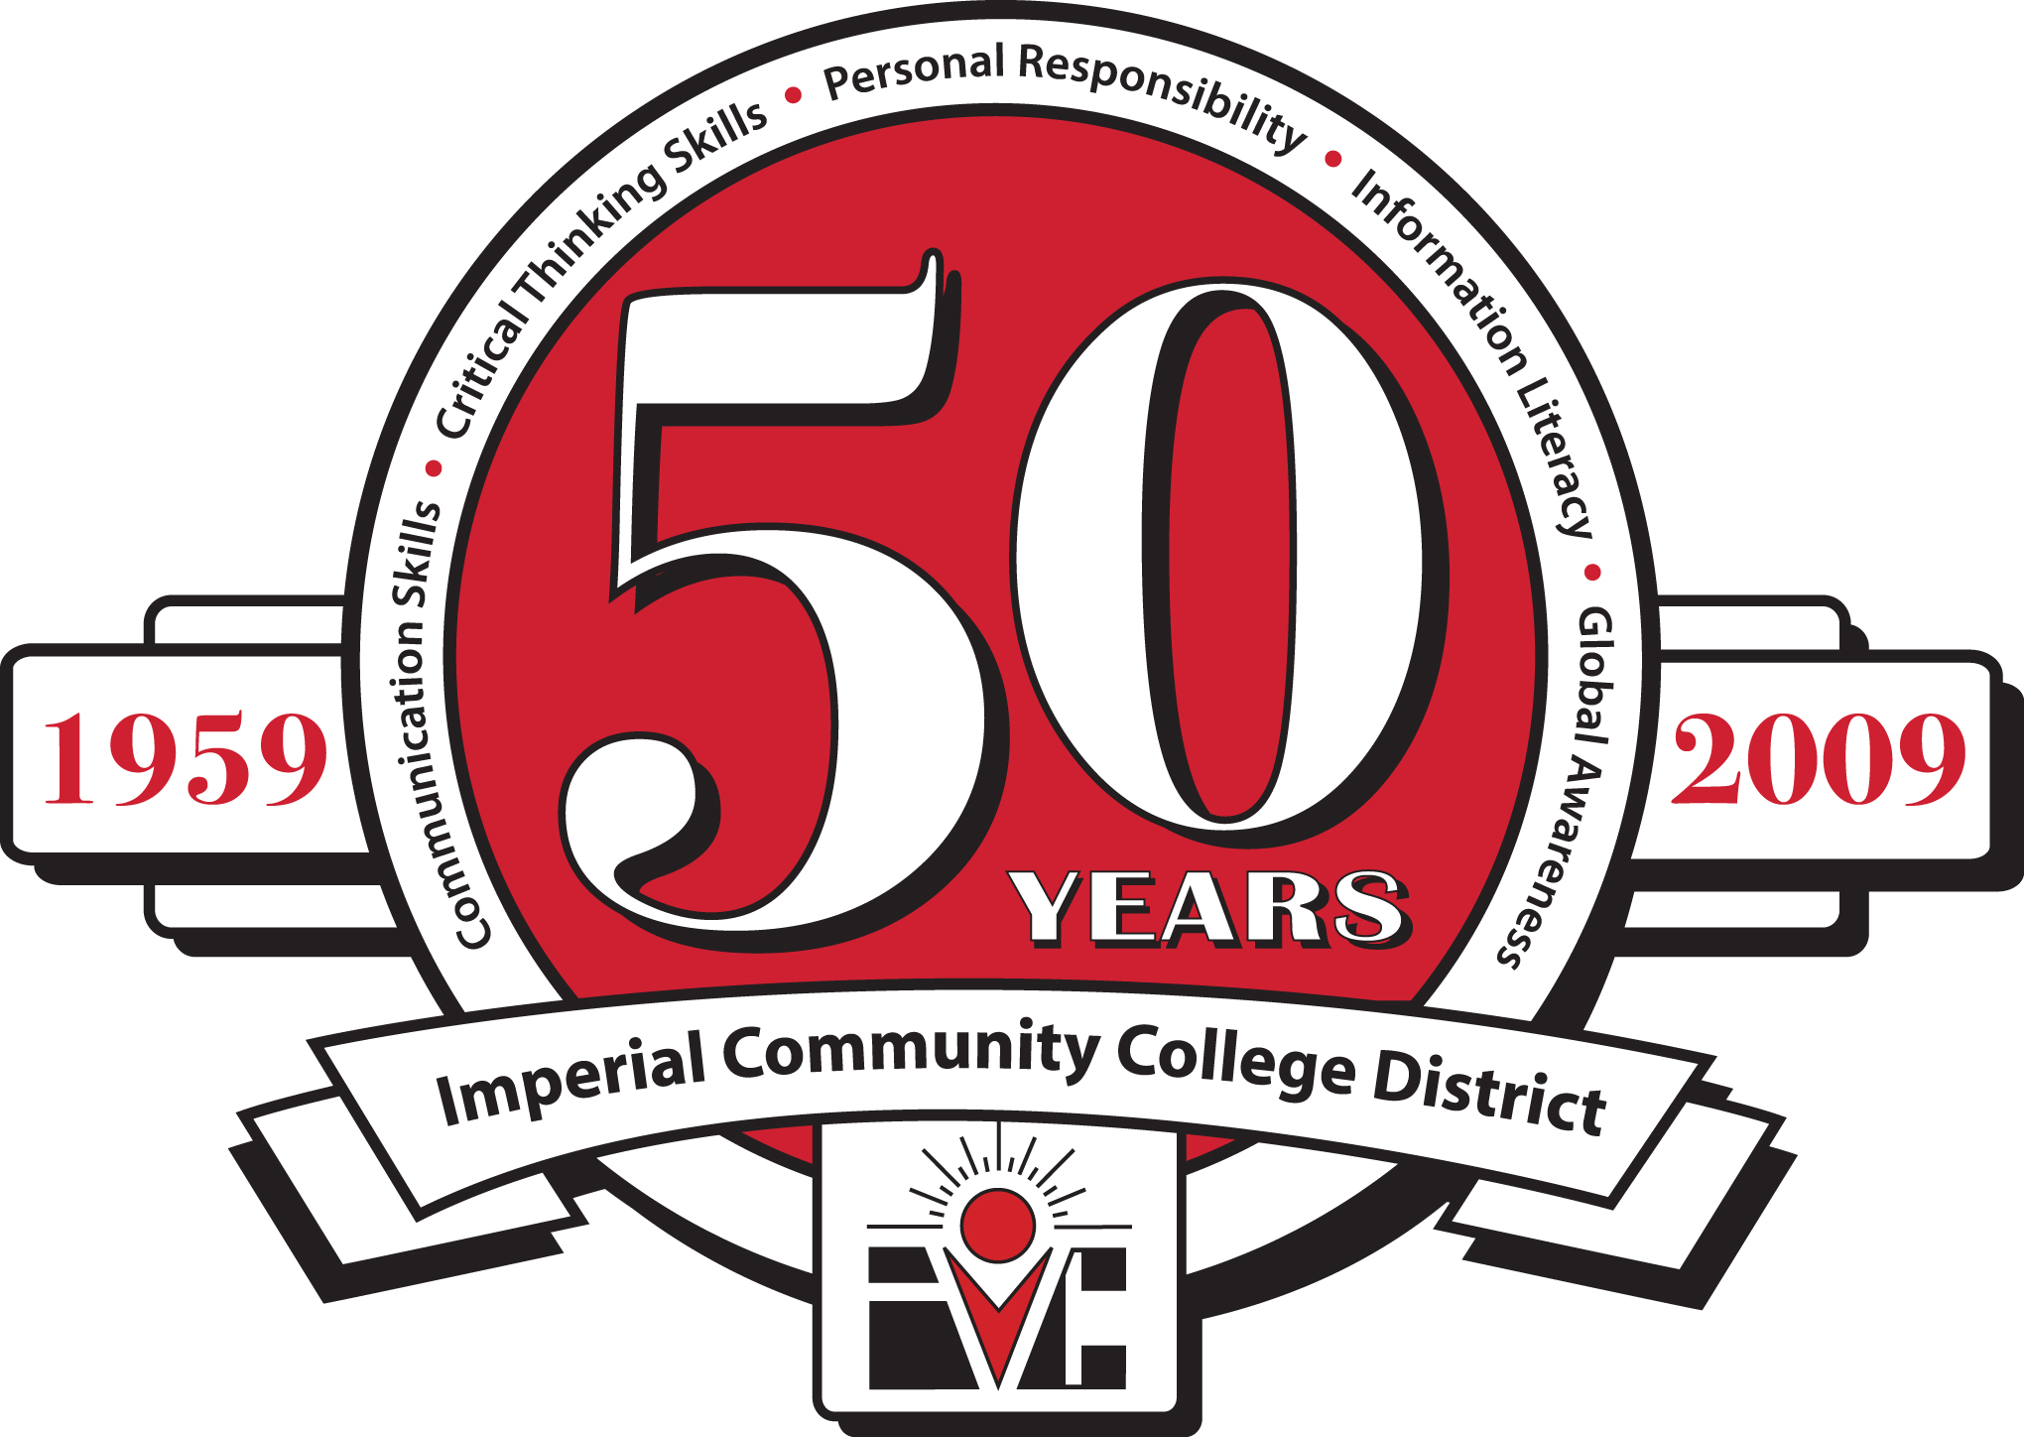

ECONOMIC AND WORKFORCE DEVELOPMENT

Perkins CTEA Meeting

Friday, April 8, 2011

8:30 AM, Board Room

|  |
| --- |
| Economic and Workforce Development  Computer Information Systems  Child Development  Automotive Technology  Automotive Collision Repair  Air-Conditioning & Refrigeration  Building Construction  Welding Technology  Fire Science  Administration of Justice  Peace Officer Standards Training (POST) |

**Agenda**

1. Call to Order
2. Approval of Minutes of February 18, 2011
3. Perkins CTEA 3rd Quarter Report (2010-2011)
4. Perkins CTEA Local Plan – Budget Prioritization (2011-2012)
5. Next Meeting – TBD
6. Adjourn