Imperial Valley College

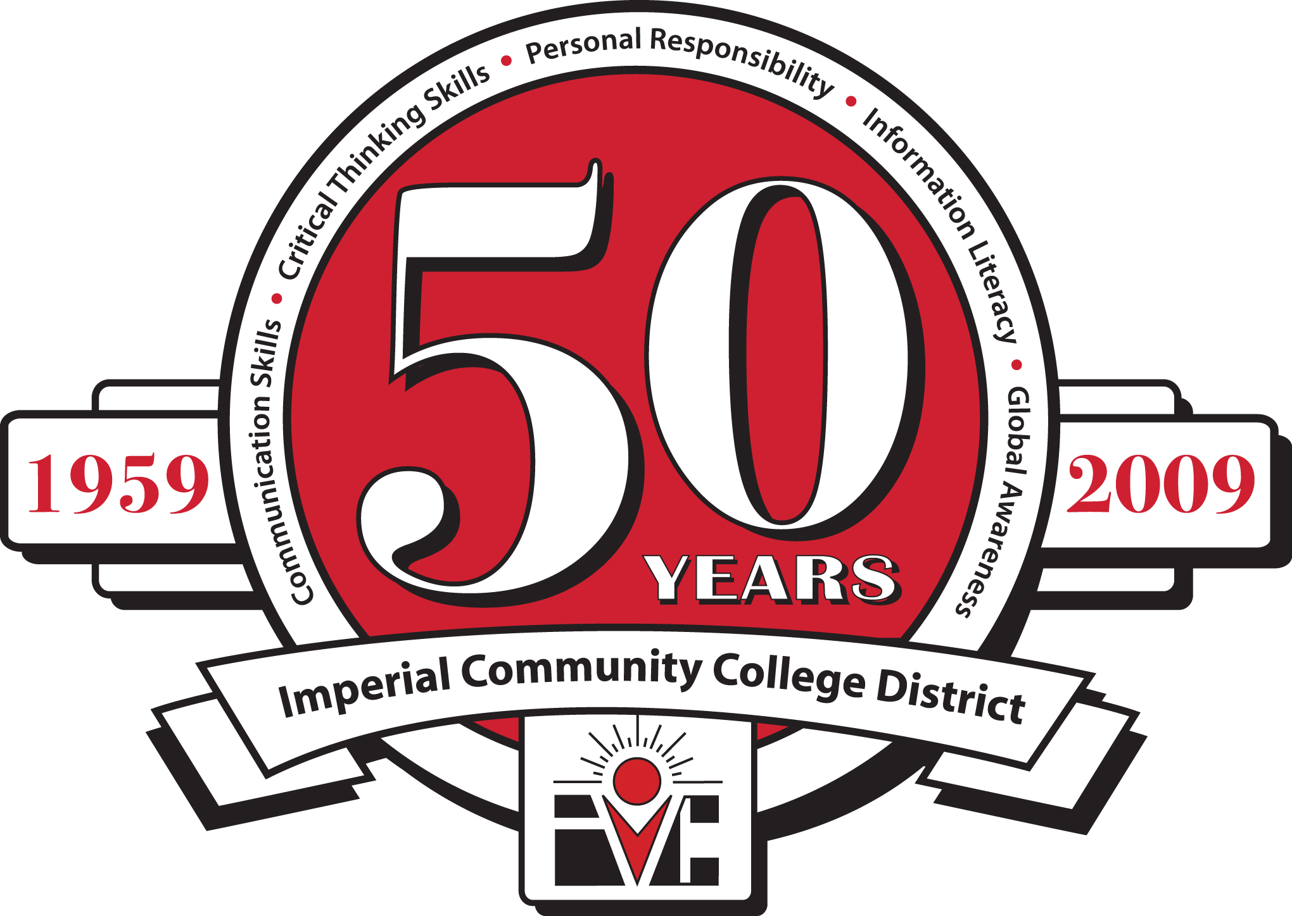

ECONOMIC AND WORKFORCE DEVELOPMENT

Perkins/CTEA Meeting

Friday, February 18, 2011

9:00 AM, Board Room

|  |
| --- |
| Economic and Workforce Development  Computer Information Systems  Child Development  Automotive Technology  Automotive Collision Repair  Air-Conditioning & Refrigeration  Building Construction  Welding Technology  Fire Science  Administration of Justice  Peace Officer Standards Training (POST) |

**Agenda**

1. Call to Order
2. Review of Minutes of October 8, 2010, May 10, 2010, & March 5, 2010
3. 2nd Quarter Report (2010-2011)
4. Local Plan (2011-2012)
5. Program Stats Matrix
6. Program Advisory Committee Meetings
7. Applied Sciences Expo
8. Next Meeting – Friday, March 18, 2011 at 9:00 AM in the Board Room
9. Adjourn