Imperial Valley College

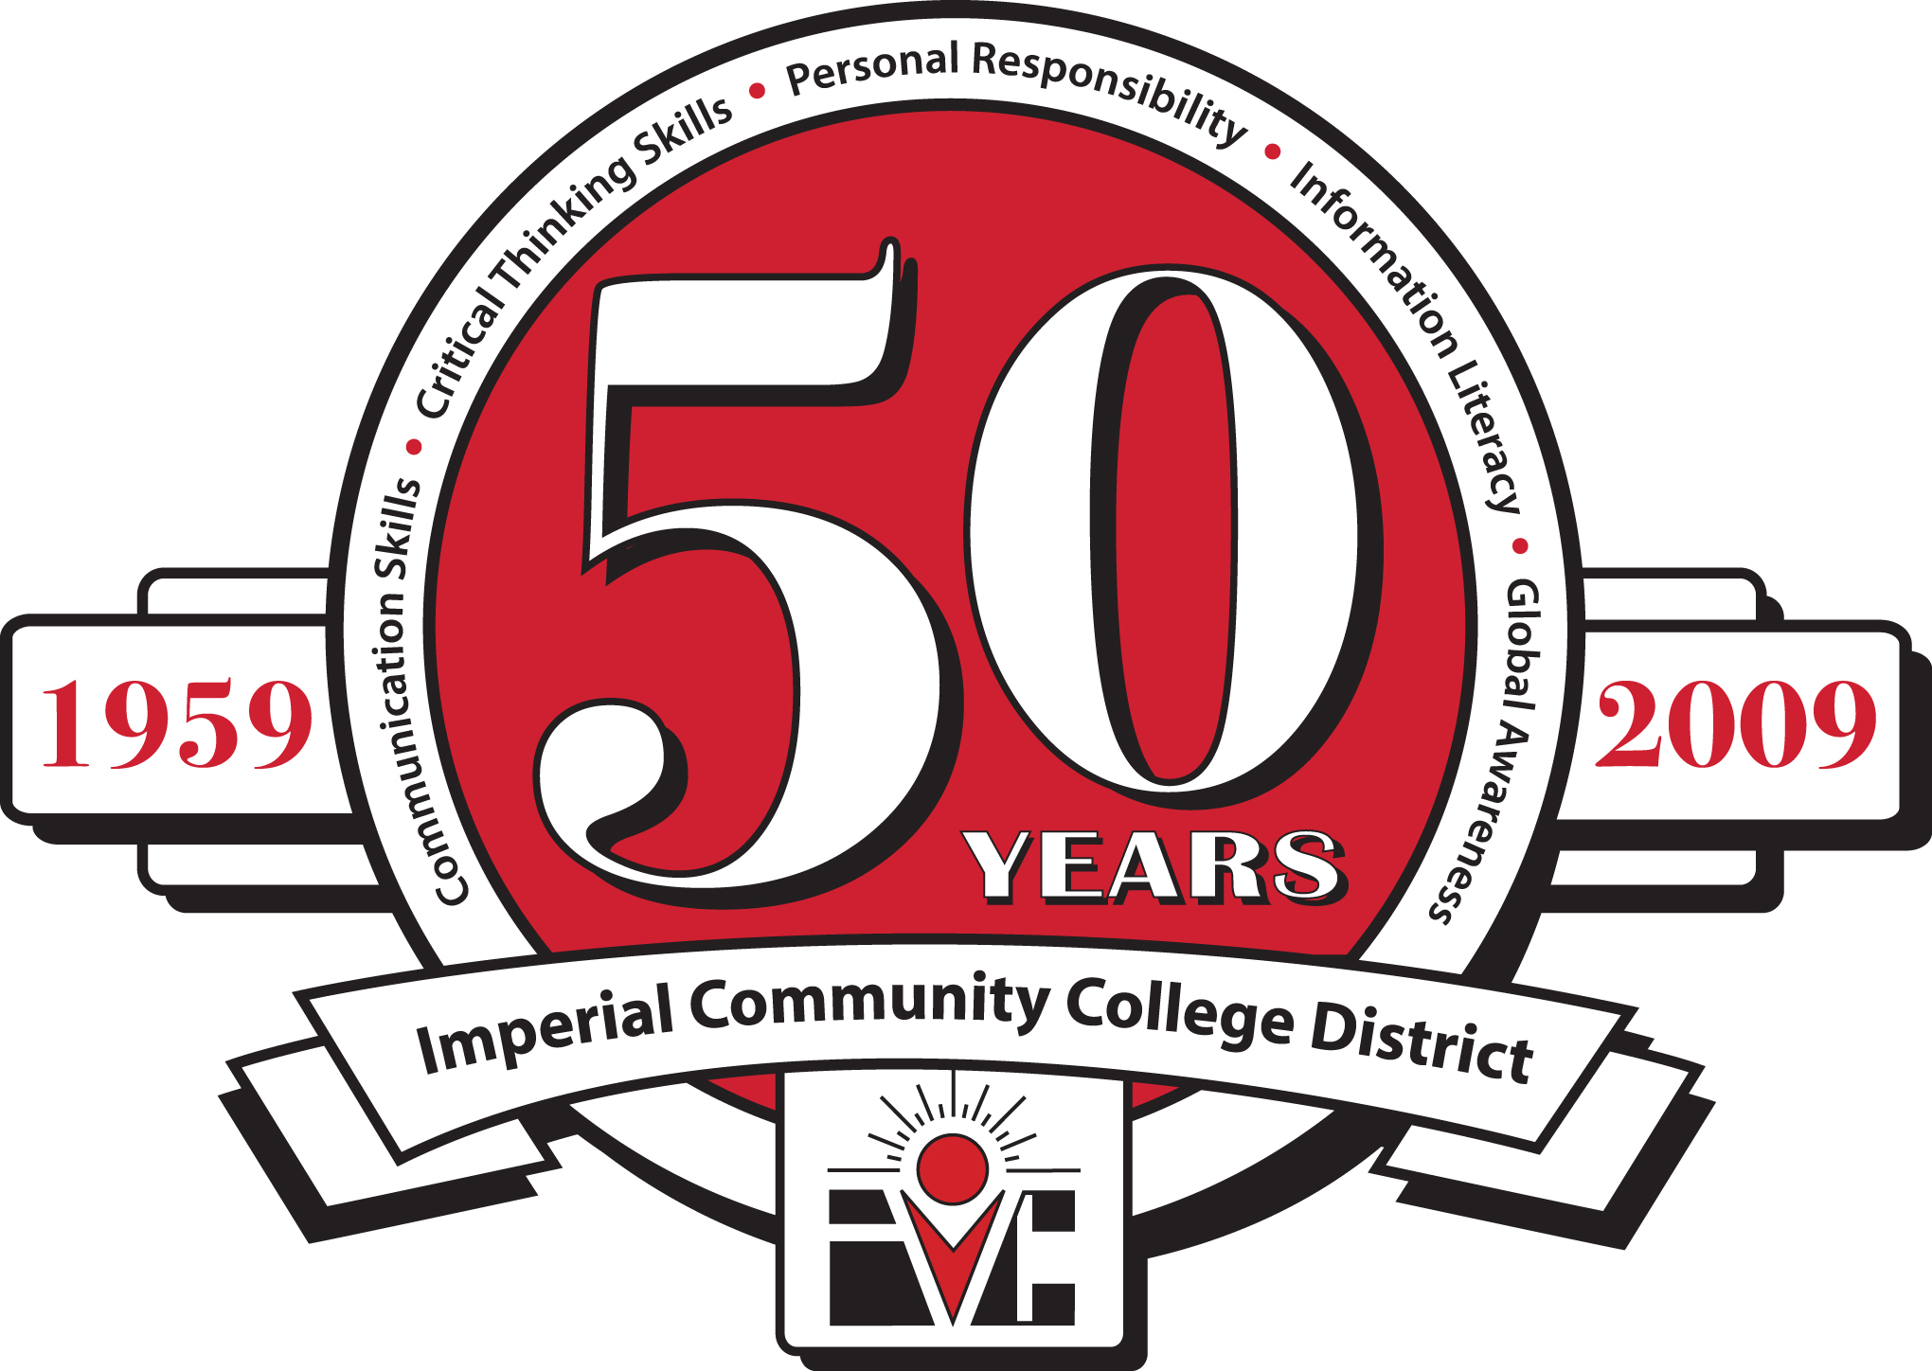

ECONOMIC AND WORKFORCE DEVELOPMENT

Perkins/CTEA Meeting

Friday, October 8, 2010

2:30 PM, Board Room

|  |
| --- |
| Economic and Workforce Development  Computer Information Systems  Child Development  Automotive Technology  Automotive Collision Repair  Air-Conditioning & Refrigeration  Building Construction  Welding Technology  Fire Science  Administration of Justice  Peace Officer Standards Training (POST) |

**Agenda**

1. Call to Order
2. Perkins/CTEA Local Process and Deadlines
3. Perkins/CTEA 2010-2011 Allocations
4. Re-allocation of $7,000.00 from Across Programs
5. Program Stats Matrix
6. College & University Day / Career Fair
7. Next Meeting – Friday, February 18, 2011 at 2:00 pm in the Board Room
8. Adjourn