Imperial Valley College

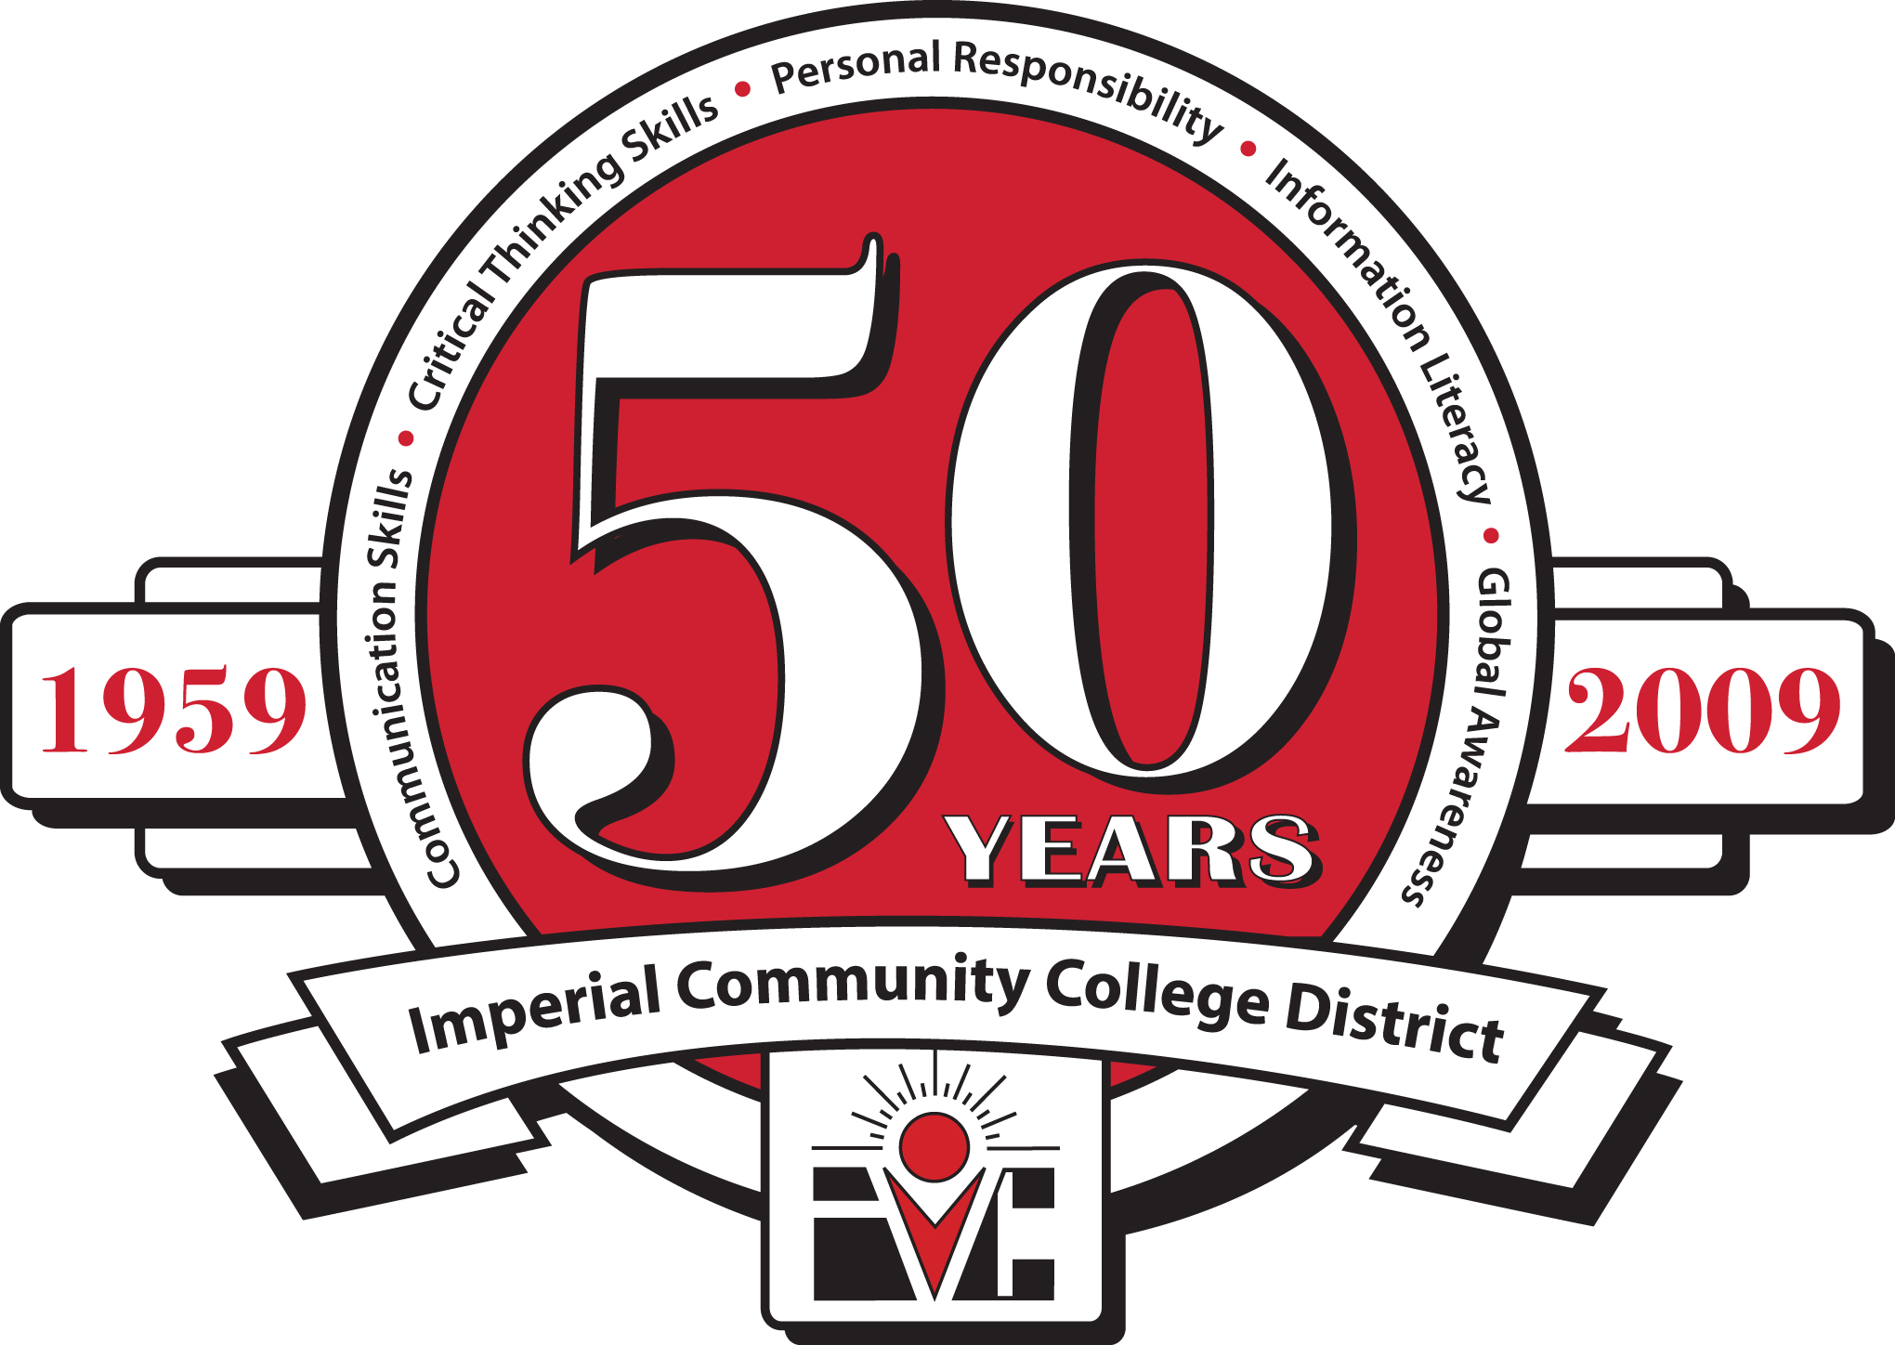

ECONOMIC AND WORKFORCE DEVELOPMENT

Staff Meeting

Friday, August 27, 2010

9:00 AM, Room 1101

|  |
| --- |
| **Members:**  Efrain Silva, Economic and Workforce Development, Chair  Patricia Robles, Economic and Workforce Development Administrative Secretary  Joe Espinoza, Economic and Workforce Development Student Employment Specialist  Vicky Figueroa, Economic and Workforce Development Student Services Technician  Maria Sell, Business Staff Secretary  Frances Arce-Gomez, Industrial Technology Staff Secretary  Jorge Guluarte, Industrial Technology Tool Room Technician  Jesse Ruelas, Industrial Technology Tool Room Technician  Mirella Cital, Extended Campus Student Services Rep  Gabriel Gonzalez, Extended Campus Student Services Technician  Melisa Vasquez, HUD & WIA Coordinator  Jose Lopez, WIA Diesel Technician Coordinator  Jesus Fidel Hernandez, WIA SET Coordinator  Ricardo Jimenez, WIA Electronic Repair Coordinator  Janeth Coronel, WIA Case Manager  Cecilia Garcia, WIA Case Manager  Analisa Veliz, WIA Office Assistant  Martha Garcia, B-GREEN Coordinator  Karina Mancillas, B-GREEN and WIA TIIP Case Manager  Susie Luna, B-GREEN Staff Secretary  Norma Santana, WIA Budget Technician |

**Agenda**

1. Call to Order
2. Introductions
3. Approval of Minutes of July 22, 2010
4. Extended Campus
5. Community Services
6. CTEA/Perkins Grant
7. Apprenticeship Programs
8. WIA Grants
9. Project B-GREEN
10. HUD
11. SB 70
12. Contract Ed
13. Adjunct Orientation
14. Other
15. Next Meeting – Friday, September 24, 2010 at 9:00 am in Room 1101
16. Adjourn